  Component One:  What are the key skills required when working in the housekeeping team? 750 words (+/- 10%)  Contribution to Overall Module Assessment: 25% | Student No: | 2210423
 | Module Title: | Operating Hotel Facilities
 | Module Code: | BMIH4006
 | Lecturer: | Kathryn Flynn
In a variety of contexts, including hotels, businesses, hospitals, and residential structures, housekeeping teams are crucial for upholding cleanliness and order. Several abilities are useful for housekeeping team members to succeed. Members of the housekeeping team should be well knowledgeable about cleaning methods, equipment, and supplies. They ought to be skilled at performing different cleaning duties, such as dusting, vacuuming, mopping, sanitising, and organising.

Time Management: Housekeeping requires effective time management, especially when operating in hectic settings (Alvarez Sainz et al., 2019). Team members should be able to set priorities, use time management strategies, and finish their jobs within allotted deadlines. Making a timetable or plan for daily or shift-based chores is essential to effective time management in housekeeping. Each activity should be given the proper amount of time, with consideration for things like room occupancy, specialised cleaning requirements, and any other obligations (Prastowo and Citra, 2022). Members of the cleaning team should set reasonable objectives for doing their work within allotted deadlines. The size of the space to be cleaned, the difficulty of the cleaning requirements, and any potential obstructions should all be taken into account. Setting realistic goals aids in maintaining motivation and reduces unnecessary stress. Large cleaning tasks can be exhausting, which makes it difficult to effectively manage time. Members of the housekeeping team should divide projects into smaller, easier-to-manage segments. This strategy enables more effective planning.

Communication skills:For cleaning teams, effective communication is essential. They frequently participate in larger teams and must communicate with managers, coworkers, and occasionally visitors (Elshaer and Marzouk, 2019). Clear communication makes it easier to understand assignments, give feedback, and deal with problems as soon as they arise. When conversing verbally with managers, coworkers, and visitors, clarity is paramount. Members of the housekeeping crew should be able to clearly convey their demands, their opinions, and any problems or worries. It is easier to communicate ideas effectively and professionally when the language and voice tone are acceptable.Messages are often conveyed through nonverbal communication, such as body language and facial expressions (Campbell et al., 2020). Members of the housekeeping staff should be aware of their nonverbal cues and make an effort to come across as amiable, approachable, and attentive.

Cleaning skills :Teams in charge of housekeeping frequently deal with unplanned events or changed priorities. Members of the team should be ready to adjust their plans, take on additional duties, and manage various cleaning demands as they arise. Depending on the setting and circumstances, several cleaning procedures may be necessary. The housekeeping team should be adaptable when it comes to various cleaning methods, supplies, and equipment. They should be willing to learn new things and adapt their techniques to the environment, whether they are cleaning hotel rooms, offices, hospitals, or any other setting. In hospitality settings, room arrangements may change, requiring housekeeping staff to adjust their cleaning techniques as needed. In relation to various types of rooms, such as suites, adjacent rooms, or special needs to alter their needs.

Customer service: In settings like hotels or guesthouses, housekeeping staff workers might directly converse with guests (Saramolee et al., 2022). It is essential to have a customer service mindset, to be courteous, and to maintain a professional demeanour in order to give visitors a positive experience. The housekeeping staff should always be friendly and approachable while interacting with visitors. A welcoming and approachable demeanour puts guests at ease and encourages them to voice their preferences or concerns. Always conduct yourself in a professional manner. The conduct of housekeeping staff members should be courteous and considerate, with a professional appearance and adherence to the norms of the establishment.

Safety hygiene skills: The housekeeping team should be familiar with chemical safety procedures. This involves being aware of how to handle, store, and use cleaning products and chemicals properly. When using chemicals, they should adhere to the directions on product labels, wear the required PPE, and make sure there is adequate ventilation. Cross-contamination must be avoided if hygiene requirements are to be upheld. To prevent transferring germs from one location to another, housekeeping employees should receive training. To do this, use different cleaning supplies and tools for various spaces, disinfect cleaning supplies after each use, and manage waste properly to stop the spread of pathogens.

Teamwork: The housekeeper can complete the jobs more successfully when there is teamwork. It is essential to offer clients effective services. It promotes growth on a personal level, raises job satisfaction, and reduces stress (Calender, 2021). Since they provide better means of resolving problems, they are essential to the success of every firm. Teams can produce significantly more rational and practical solutions. The assimilation of the team production has been impeded by various problems. This has enabled them to break the work up into smaller chunks and complete it more rapidly (Sonnenschein, 2021). It is one of the greatest ways to ensure that the individual with the most talent completes the assignment that is appropriate for him.

Word Count | 823

Component Two:
Contribution to Overall Module Assessment: 25%
In this scenario – You have just been promoted to team leader for a floor within the hotel. A guest complains that on their arrival, their room had not been properly cleaned. Create an action plan and answer the following questions.

Problem | Why did it happen? | What are you going to do? | How will you prevent this from happening in the future? | What measures would you introduce to improve team effectiveness?
Attitude of staff | The workers misbehaved with clients. The customers were annoyed by the workers' attitude. It has developed a negative impression on the hotel staff. | A negative behaviour will destroy the reputation of the hotels. I will try to provide effective training and development on the basic etiquettes necessary and customer service. I will give them sessions on how to behave properly with clients. | I won't permit them to perform any immoral tasks at work. I will give them quality instruction and development.I will expand opportunities for advancement | In order to improve the atmosphere at work, I will provide training sessions on instilling positive attitudes in the workforce.I will talk to the staff members and respond to their issues both professionally and personally.  I'll try to involve the staff in as many enjoyable activities as I can.
Lack of communication | The hotel personnel's issues were addressed too slowly by the staff. This hotel staff atmosphere irritated the patrons. | Poor communication will damage the hotel's reputation (Tiwari et al., 2023). So that there is no misunderstanding among the personnel, I will contact them (Back et al., 2020). So that there is no delay in communication, I will allow them to connect via internet gadgets. | By providing instruction in fundamental housekeeping courses, I will avoid misunderstandings. The elders, who are professionals in this area, will provide direction to the cleaning crew.  will give the staff the room they need to voice their concerns. I shall increase the operations' flexibility to ensure that there is balance between them. | The implementation of the hotel communication software will ensure effective communication.  The level of communication can be improved and hurdles in the workplace can be avoided by creating a mobile-friendly workplace.  The experience of guests will be improved with the use of easily accessible information.
Dirty Rooms | The rooms were dirty and did not have hygiene. The customers are not satisfied to visit the place. | Keep the staff informed of the safety procedures. Strict health and safety regulations must be upheld (Rawal et al., 2021). | Will investigate this issue more thoroughly to eliminate the possibility of problems arising again (Quick, 2019).  One of the best methods to improve communication is personalization.  It will add to positive reviews and improve the brand recognition of the hotels' employees who are knowledgeable about safety procedures. Strict health and safety regulations must be upheld (Rawal et al., 2021). | Safety and cleaning precautions must be ensured so that every customer is satisfied. Enhanced disinfecting protocols should be incorporated (Suksutdhi, 2020). Cleaning procedures and guidelines must be established to ensure clean rooms.
Technical skills | Customers encountered a weak WIFI signal in the hotel. The bad connection infuriated the customers. | I will give my consumers a strong internet connection. I will make sure that consumers and visitors have a secure online experience. | I will use efficient digital tools to avoid problems caused by a lack of internet (Horst and Sinanan, 2021). The IT team will keep an eye on the numerous unidentified objects that are connected to Wi-Fi (Guo et al., 2019). | I will appoint a knowledgeable IT manager to investigate this situation. The hotel IT department will ensure that customer data is protected and that the secured Gateway complies with industry requirements (Shin et al., 2019). I will see if the internet connection is operational.
Ineffective customer services | The consumers were not dissatisfied or dissatisfied as a result of the housekeepers' poor services. | I will provide them with sufficient training to ensure that they are prepared to provide the consumers with quality services (Robina-Ram et al., 2021). | By educating them on hotel communication protocols, I can stop this from happening. The use of digital applications is necessary to enhance staff communication.  To share the special visitors' personal preferences, group conversations must be made. | will improve the communication system by accelerating reporting and response times.  Every communication will be incorporated into the hotel's communication system.  To satisfy every customer, safety and cleaning procedures must be taken. Enhanced disinfection procedures ought to be used. To guarantee clean rooms, cleaning policies and rules must be implemented.  Room access and contact-free check-in are included.  For the hotel staff, PPE and advanced training must be implemented.

Component Three:
Contribution to Overall Module Assessment: 50%
Your task is to create and prepare a presentation following the detailed scenario provided below.

As the floor housekeeping manager and given the recent guest complaints you need to put together a basic training presentation for your colleagues within the housekeeping team to get the best out of them, ensure that brand standard is being achieved and that Health and Safety procedures are also being followed.

1. Introduction to Housekeeping

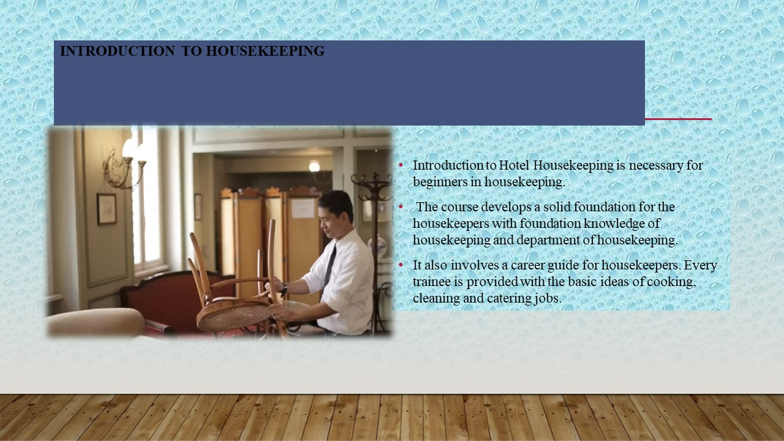

Training Notes: Introduction to Hotel Housekeeping is necessary for beginners in housekeeping. The course develops a solid foundation for the housekeepers with foundation knowledge of housekeeping and department of housekeeping. It also involves a career guide for housekeepers. Every trainee is provided with the basic ideas of cooking, cleaning and catering jobs.

2.All about Housekeeping

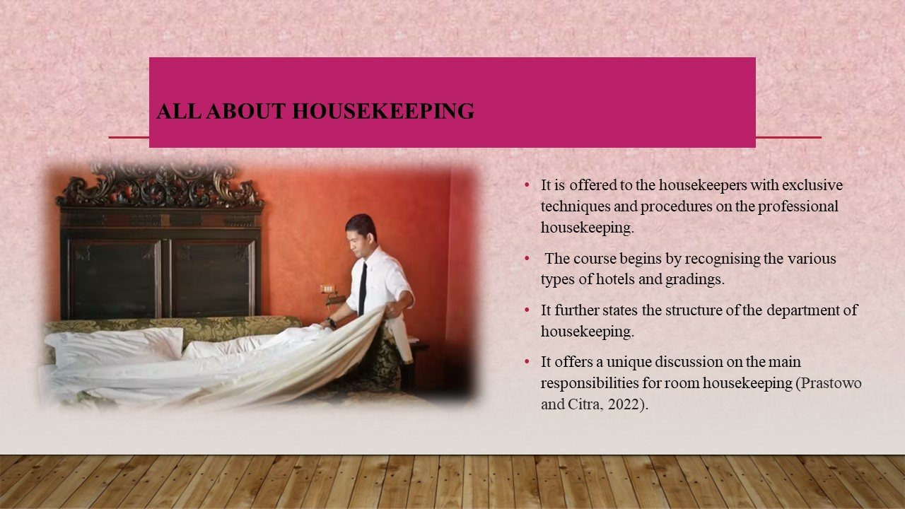

Training Notes: It is offered to the housekeepers with exclusive techniques and procedures on the professional housekeeping. The course begins by recognising the various types of hotels and gradings. It further states the structure of the department of housekeeping. It offers a unique discussion on the main responsibilities for room housekeeping (Prastowo and Citra, 2022). The training will help the students become competent in all areas. The staff members become more effective and efficient thanks to this particular course. As a result, the hotels require their staff to fulfil their desired goals and objectives. The hotels must offer this specific course to train the housekeeping crew so that they can provide consumers with excellent services. This particular course will assist the housekeeper in meeting the wants and demands of the clients in order to earn their good feedback. The customer reviews are essential for boosting the hotels' brand recognition. They will learn how to adjust to any situation by learning about housekeeping. The housekeepers will benefit from this course by being more confident in their ability to complete the task at hand. Lessons are offered with the help of guided learning which can be accomplished across many sessions.
3.Advance Cleaning
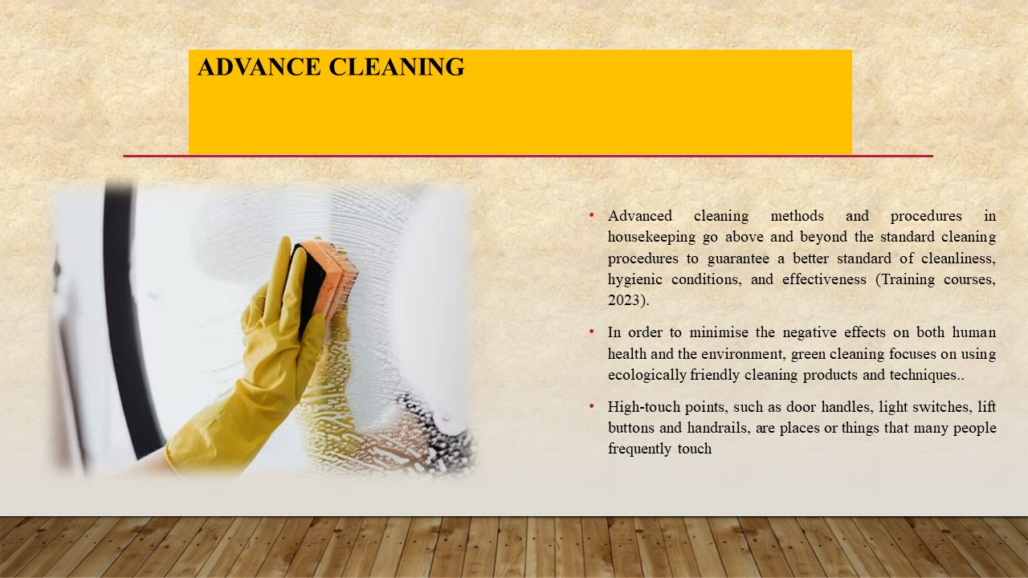

Training Notes: Advanced cleaning methods and procedures in housekeeping go above and beyond the standard cleaning procedures to guarantee a better standard of cleanliness, hygienic conditions, and effectiveness (Training courses, 2023). In order to minimise the negative effects on both human health and the environment, green cleaning focuses on using ecologically friendly cleaning products and techniques. This involves employing recycling and waste reduction programmes, utilising non-toxic, biodegradable cleaning products, microfiber cloths for dusting and cleaning, and so on. High-touch points, such as door handles, light switches, lift buttons and handrails, are places or things that many people frequently touch. A hygienic atmosphere can be achieved by paying special attention to cleaning and disinfecting these areas with the proper disinfectants a clean and healthy atmosphere, adequate indoor air quality is crucial. The spread of airborne contaminants can be reduced by performing routine HVAC maintenance, changing the air filters, and upgrading ventilation systems.

4.Infection Control and Cleaning

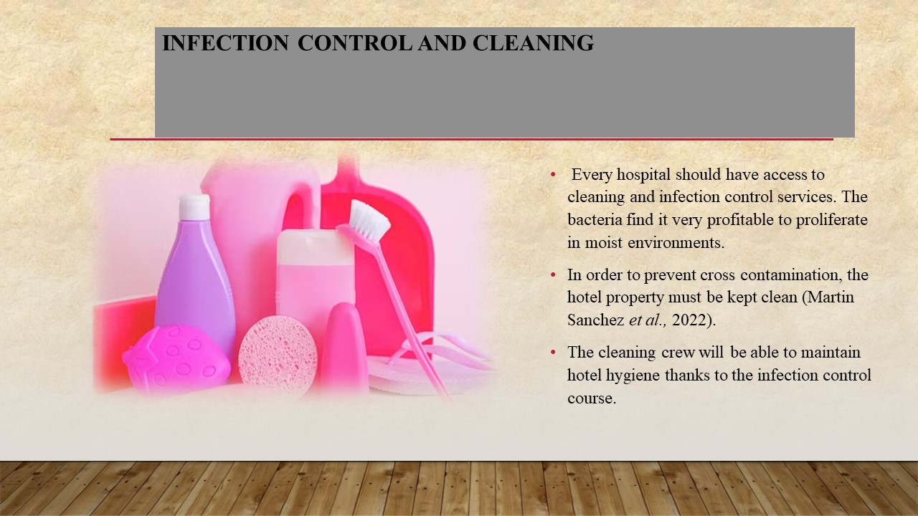

Training Notes: Every hospital should have access to cleaning and infection control services. Since it stops microorganisms from spreading to every nook and cranny of the hotels, infection control is absolutely essential. The bacteria find it very profitable to proliferate in moist environments. In order to prevent cross contamination, the hotel property must be kept clean (Martin Sanchez et al., 2022). The cleaning crew will be able to maintain hotel hygiene thanks to the infection control course. The practices required for infection control in the workplace must be implemented. Both the hotel management and the clients will gain additional advantages from this training session.
5.Sanitising and Cleaning
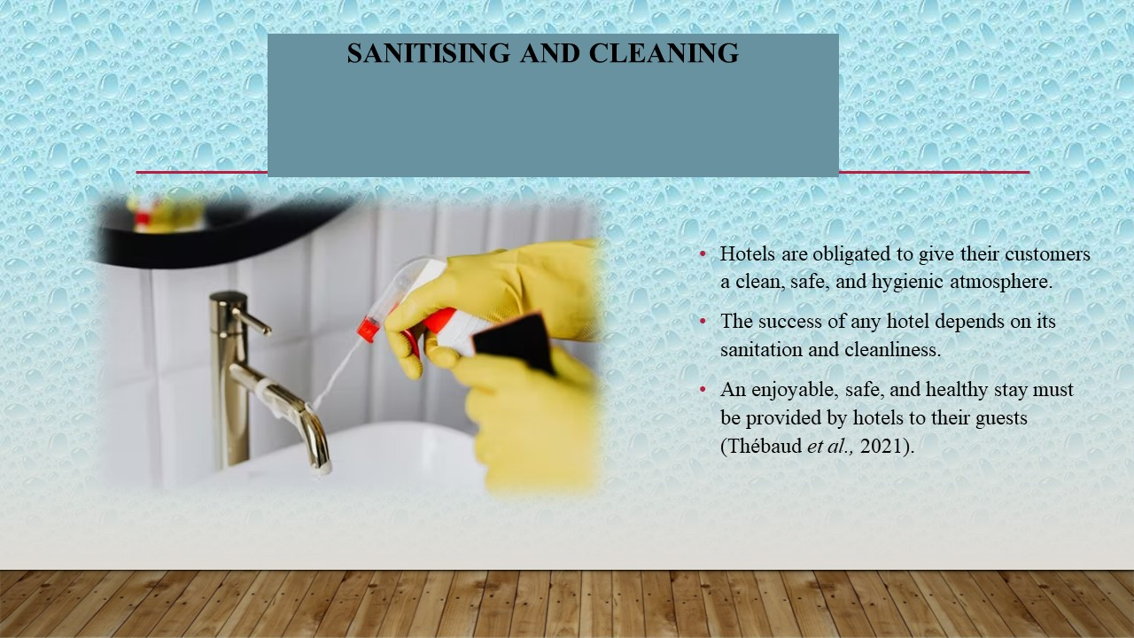

Training Notes: Hotels are obligated to give their customers a clean, safe, and hygienic atmosphere. The success of any hotel depends on its sanitation and cleanliness. An enjoyable, safe, and healthy stay must be provided by hotels to their guests (Thébaud et al., 2021). To do this, hotels must implement and enforce stringent cleaning and sanitation practices throughout the entire property. To achieve this, high-contact surfaces like furniture, bathroom fixtures, work surfaces, bedding and light switches must be routinely sanitised. It's crucial to offer thorough training courses to housekeeping personnel on modern cleaning methods and procedures. The best way to ensure that staff members have the knowledge and abilities necessary to successfully complete complex cleaning duties is to regularly update them on the newest cleaning techniques, supplies, and industry trends.
The floors and carpets should be vacuumed and mopped often. Every single member of the housekeeping team needs to take this particular course. The grounds, rooms, and lounges of the hotel will be cleaner after cleaning and sanitising.

6.Covid Protocols
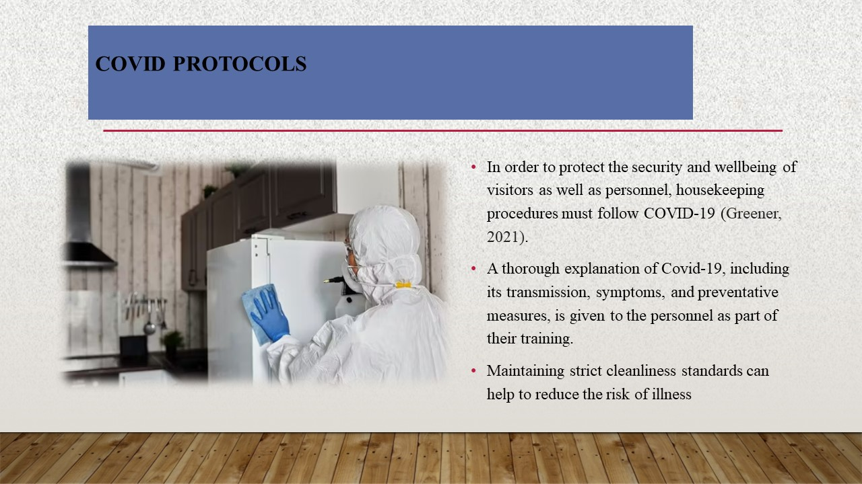

Training Notes: In order to protect the security and wellbeing of visitors as well as personnel, housekeeping procedures must follow COVID-19 (Greener, 2021). A thorough explanation of Covid-19, including its transmission, symptoms, and preventative measures, is given to the personnel as part of their training. Maintaining strict cleanliness standards can help to reduce the risk of illness. These workers are provided to teach how to wear PPE, such as masks, gloves, and other essential protective equipment. Teaching them the proper ways to put on, take off, and discard PPE to avoid cross-contamination are necessary. By highlighting the significance of regular, effective handwashing. Teach employees how to properly wash their hands with soap and water for at least 20 seconds. Showing how to use hand sanitizers with at least a 60% alcohol level if handwashing facilities are not easily accessible.

7.Housekeeping Safety

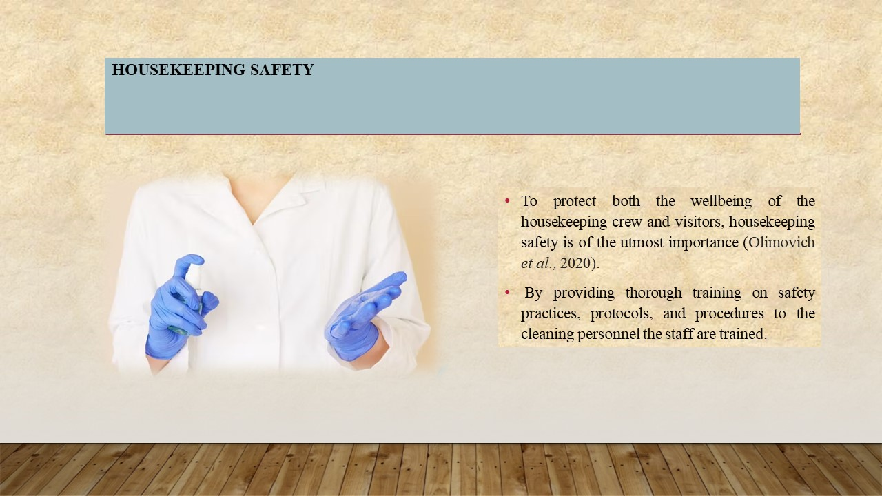

Training Notes: To protect both the wellbeing of the housekeeping crew and visitors, housekeeping safety is of the utmost importance (Olimovich et al., 2020). By providing thorough training on safety practices, protocols, and procedures to the cleaning personnel the staff are trained. This ought to include instruction in safe work procedures, ergonomics, and the correct use of machinery and chemicals. To make sure that personnel are aware of and follow safety requirements, regularly reinforce training. It is essential to guarantee that cleaning staff has access to personal protective equipment and is instructed in its proper use. Encouraging employees to constantly wear PPE and offer instructions for correct donning, doffing, and disposal.

8.Safety For Hotels

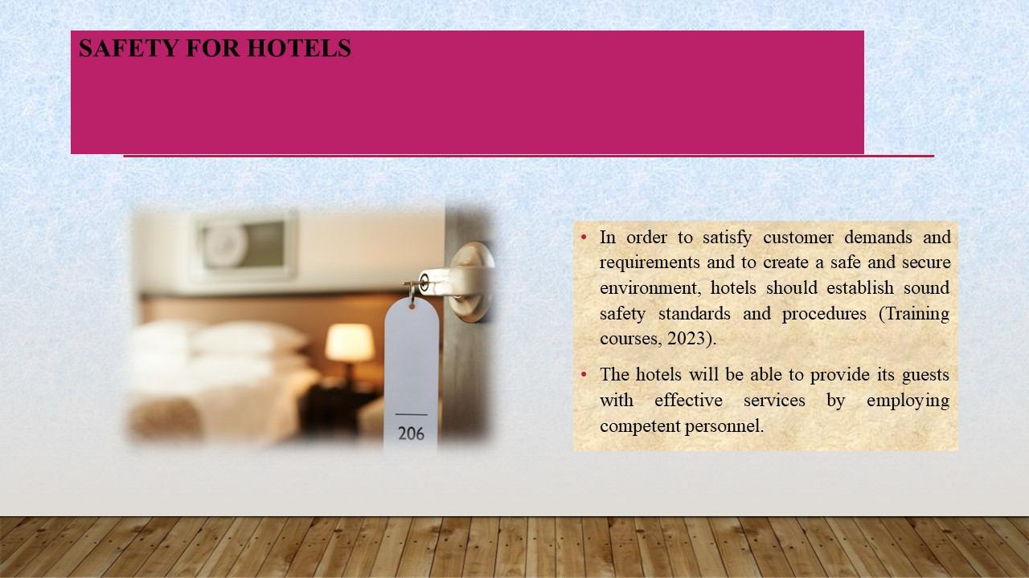

Training Notes: In order to satisfy customer demands and requirements and to create a safe and secure environment, hotels should establish sound safety standards and procedures (Training courses, 2023). The hotels will be able to provide its guests with effective services by employing competent personnel. The safety of hotel guests and staff is of the utmost importance. In order to maintain a secure environment, hotels should establish effective safety protocols and procedures, including having well-trained security personnel, ensuring that all entrances have enough security measures in place, holding regular fire drills and hazard identification exercises, conducting background checks on all staff, and installing CCTV cameras in public areas. Additionally, accommodations should set up an emergency notification system that they can use to tell visitors of any potential hazards (Mullins and Dossor, 2013). To provide a clean and sanitary environment, it is crucial to implement effective cleaning and sanitation processes. Provide hand sanitising stations and emphasise the importance of washing hands often all over the property. Cleaning and disinfecting frequently used objects and high-touch surfaces on a regular basis is required for workers to learn. It is important to instruct personnel and visitors on good respiratory etiquette, such as covering coughs and sneezes.

9.Housekeeping Inspections
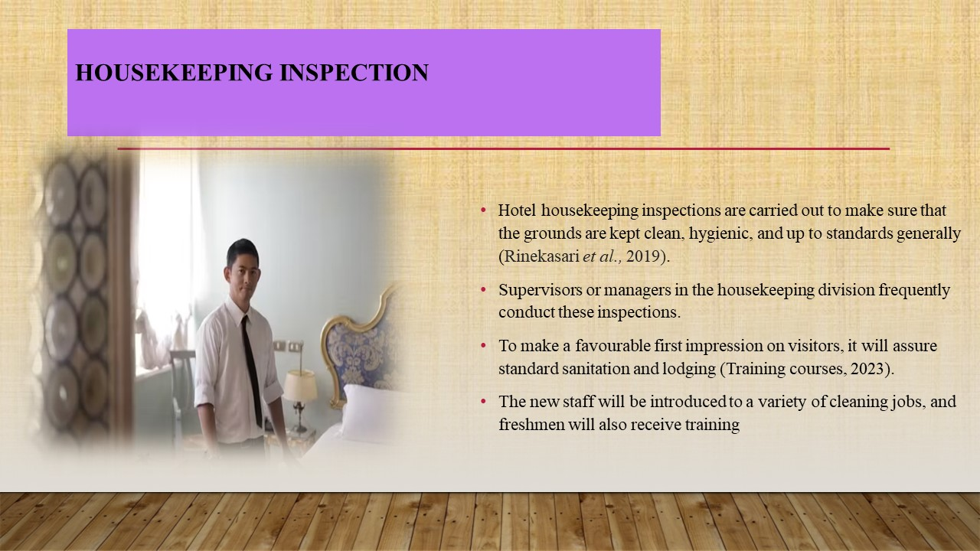

Training Notes: Hotel housekeeping inspections are carried out to make sure that the grounds are kept clean, hygienic, and up to standards generally (Rinekasari et al., 2019). Supervisors or managers in the housekeeping division frequently conduct these inspections.
The hotel will give a free training session to provide proper rules and efficient procedures for inspecting guest rooms, restrooms, and hallways. To make a favourable first impression on visitors, it will assure standard sanitation and lodging (Training courses, 2023). The new staff will be introduced to a variety of cleaning jobs, and freshmen will also receive training. Individuals must master the varied cleaning and polishing requirements for housekeepers. This course's focus, which includes bathroom and hallway inspections as well as room inspections, is sufficient.

10.Aon Hewitt Engagement Model

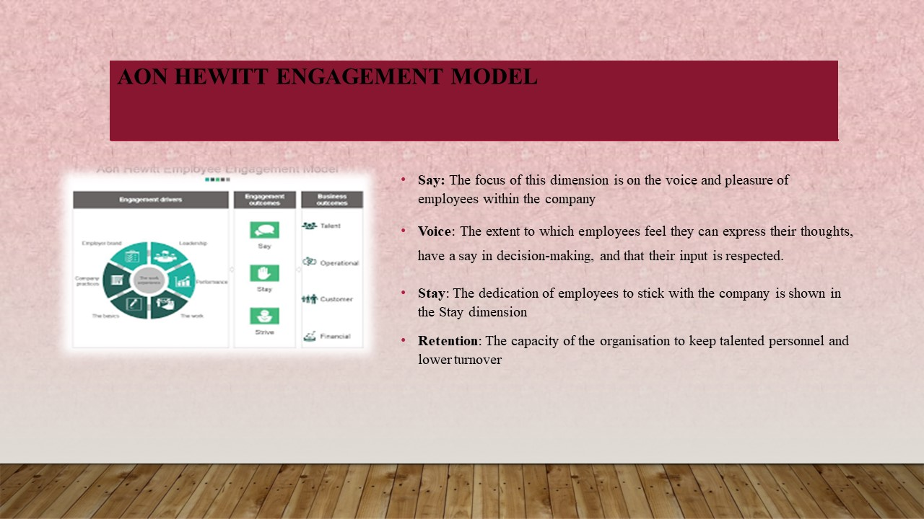

Training Notes: Say: It is an employee engagement model which assists to retain quality staff in organisation.
The focus of this dimension is on the voice and pleasure of employees within the company. It comprises elements like:
Employee satisfaction is the degree to which they are happy with their jobs, pay, benefits, and overall working environment (Bridger, 2018).
Voice: The extent to which employees feel they can express their thoughts, have a say in decision-making, and that their input is respected.
Stay: The dedication of employees to stick with the company is shown in the Stay dimension. It comprises elements like:
Employees' loyalty to the company and likelihood of staying on as employees are measured by their intention to stay.
Retention: The capacity of the organisation to keep talented personnel and lower turnover.
Strive: The Strive dimension is concerned with the drive and initiative of employees. It consists of elements like:
Employee engagement, enthusiasm, and motivation levels are measured by this term.
Discretionary effort refers to an employee's willingness to put in more effort and energy than is strictly necessary to perform their work duties in order to advance the organization's objectives.
Share: Employee advocacy for the company is a component of the Share dimension. It comprises elements like:
Employees' propensity to talk well of their employer, suggest it as a great place to work, and aggressively promote its goods and services is known as advocacy.
Organisational Citizenship Behaviour: The display of behaviours that contribute to the overall success of the organisation, such as assisting coworkers, taking on extra duties, and taking part in activities outside of one's specialised function.

References
- Alvarez Sainz, M., Ferrero, A.M. and Ugidos, A., 2019. Time management: skills to learn and put into practice. Education+ Training, 61(5), pp.635-648.
- Back, A., Tulsky, J.A. and Arnold, R.M., 2020. Communication skills in the age of COVID-19. Annals of internal medicine, 172(11), pp.759-760.
- Bridger, E. 2018. Employee engagement: a practical introduction. 2nd ed. HR Fundamentals. London: CIPD and Kogan Page.
- Calender, M., 2021. The Impact of Teamwork Among Staff in Tourism and Hospitality Organizations on Business Development. Journal of Law and Economics, 2(2), pp.30-32.
- Campbell, S., Campbell-Phillips, S. and Phillips, D., 2020. Lack of communication between management and employees. SIASAT, 5(3), pp.32-39.
- Choy, M., Cheng, J. and Yu, K., 2021. Evaluating the environmental sustainability strategies of the housekeeping department: the case of an international hotel chain in Hong Kong, China. Tourism Critiques: Practice and Theory, 2(1), pp.115-132.
- Cottrell, S. (2019) The Study Skills Handbook. 5th ed. London: Red Globe Press.
- Elshaer, A.M. and Marzouk, A.M., 2019. Vocational skills training in higher tourism and hospitality education in Egypt: An analytical framework. International Journal on Recent Trends in Business and Tourism (IJRTBT), 3(3), pp.12-26.
- Greener, S., 2021. Exploring remote distance learning: what is it and should we keep it?. Interactive Learning Environments, 29(1), pp.1-2.
- Guo, X., Cheng, A. and Pavlou, P., 2019. Skill-biased technical change again? Estimating the effect of TaskRabbit on local employment in the housekeeping industry.
- Hasanah, H. and Malik, M.N., 2020. Blended learning in improving students’ critical thinking and communication skills at University. Cypriot Journal of Educational Sciences, 15(5), pp.1295-1306.
- Horst, H. and Sinanan, J., 2021. Digital housekeeping: Living with data. New Media & Society, 23(4), pp.834-852.
- Leiter, M. P. and Bakker, A. B. (2010) Work Engagement : A Handbook of Essential Theory and Research.Hove [England]: Psychology Press.
- Mullins, L. and Dossor, P. (2013) Hospitality Management and Organisational Behaviour. 5th ed. Harlow:Pearson.
- Olimovich, D.I., Bakhtiyorovich, T.M. and Salimovna, N.G., 2020. Improving of personnel training in hotel bussines. Academy, (2 (53)), pp.18-19.
- Prastowo, I. and Citra, R.P., 2022. Housekeeping Housekeeping Development For Homestay Managers In Kampung Purba Tourism Village, Dayu, Gondangrejo Karanganyar. TEKNOLOGI TEPAT GUNA, 3(2), pp.100-110.
- Quick, L. (2020) Managing Events. Real Challenges, Real Outcomes. London: SAGE Publications Ltd.
- Raghubalan, G. and Raghubalan, S. (2016) Hotel Housekeeping - Operations And Management. 3rd ed.India: Oxford University Press.
- Rawal, Y.S., Pal, S., Bagchi, P. and Dani, R., 2020. Hygiene and safety: a review of the hotel industry in the era of COVID-19 pandemic. Bioscience Biotechnology Research Communications, 13(10), pp.79-83.
- Rinekasari, N.R., Jubaedah, Y. and Sobariah, S.N., 2019. Standard Operating Procedure of Housekeeping Adaptation: The Development of Assessment Tools in Cleaning Bathroom Practices at Vocational High School. KnE Social Sciences, pp.150-161.
- Saramolee, A., Hareebin, Y., Boonkaew, S., Aujirapongpan, S. and Jutidharabongse, J., 2022. Professional skills development affecting organizational learning and corporate performance: an empirical study in Thailand. TEM Journal, 11(1), p.234.
- Shin, H., Perdue, R.R. and Kang, J., 2019. Front desk technology innovation in hotels: A managerial perspective. Tourism Management, 74, pp.310-318.
- Sonnenschein, K., 2021. ‘It’s Important for Us to Know How to Do Teamwork’: Perceptions of Chinese International Hospitality Students Regarding Teamwork Skills. Journal of China Tourism Research, 17(2), pp.309-322.
- Suksutdhi, T., 2020. Service Quality Improvement for Senior Tourists at Hotels and Resorts in the Perception of Service Providers: Nakhon Ratchasima, Thailand. The EUrASEANs: journal on global socio-economic dynamics, (6 (25)), pp.56-61.
- Tiwari, A., Singh, M. and Dahiya, A., 2023. The Impact of Outsourcing of Hotel Housekeeping Services on Hotel Performance: a Study on 5-Star Hotels of Delhi NCR. International Journal of Professional Business Review, 8(1), pp.e0905-e0905.
- Training courses (2023) 10 housekeeper training courses, EdApp Microlearning Programs. Available at: https://www.edapp.com/10-housekeeper-training-courses/ (Accessed: May 29, 2023).

