L5 - Distributed Intelligence Systems (ACDA5018) (EEE version)

Gomer Morgan-Gray
2316794
2026

Abstract
This report presents the design, implementation, and analysis of a distributed control system, using a point to multipoint communication architecture applied to an automotive lighting application. The system consists of a master microcontroller communicating via the I²C bus to two slave devices in control of the rear lighting functions of an automobile including brake, hazard, reverse and indicator lights.
The hardware design made use of PIC16F88 microcontrollers and was initially developed within the Proteus simulation software before later implementation physically on a breadboard. Communication between devices was facilitated via a custom packet structure incorporating addressing, variable data length and Cyclic Redundancy check (CRC-8) to improve reliability and support future system expansion.
Software was developed in the C programming language making use of the CCS for PIC Compiler. An Event driven approach was used to reduce unnecessary bus traffic and improve overall system performance.
Testing both in simulation and hardware demonstrated the expected behavior, with both slave devices responding correctly and reliably to user inputs. Several limitations and future improvements have also been recognized with the chosen architecture such as the dependence on a single master device for communication and potential limitations of the I²C bus with larger systems.
The proposed system effectively demonstrates the practicality of distributed embedded control systems within an automotive environment to achieve a reliable, modular and scalable solution.

Contents
Abstract 2
1 – Introduction 4
2 – Background Research 5
2.1 – Point To Point Transmission 5
2.2 – Point To Multipoint Transmission 5
2.3 – Multi-master Transmission 6
2.4 – Comparison and Relevance to this project 6
3 – System Design 7
3.1 – System Overview 7
3.2 – Hardware Selection 7
3.3 – Proteus Implementation 8
4 – Software Development 9
4.1 – Program Development Approach 9
4.2 – Master Program 10
4.3 – Slave Program 11
4.4 – CRC Implementation 13
5 – Analysis and Evaluation 14
5.1 – System Performance evaluation 14
5.1.1 – Simulation 14
5.1.2 – Breadboard 15
5.2 – System Limitations 16
5.3 – Quality Management and Continuous improvement 16
6 – Conclusion 16
References 18
Appendix 19
Appendix 1 – Full Simulation test Results 19
Appendix 2 – Full Breadboard Test Results 21
Appendix 3 – Pic Programming Setup 23

1 – Introduction
Distributed systems are widely used within embedded and control systems, and are commonly used within automotive applications, where multiple control units (ECU’s) are used and must share information between each other. Rather than relying on a single controller distributed systems distribute tasks between several controllers, this improves modularity, scalability and reliability.
In automotive applications safety and reliability are essential factors whilst designing a system. Distributed systems lend themselves to this application as they avoid single failure points distributing responsibility across several devices, where in the case of a failure it is limited to that device.
The focus of this report was the design and implementation of a distributed control system used for a vehicle lighting application. The system controls the rear lighting functions of a car, incorporating essential features such as brake, hazard, and reverse lights. A Master slave, point to multipoint architecture was utilized, where a single central microcontroller distributes control signals to two slave devices using a packet-based communication method over an I²C bus.
The system was designed and simulated in Proteus then later tested on breadboard. Software was developed in C making use of the CCS for PIC compilers. This report presents the research, design and evaluation of a simple distributed system and demonstrates how they can be applied to an automotive environment.

2 – Background Research

2.1 – Point To Point Transmission
A point-to-point architecture is the simplest form of communication system, consisting of two devices with a dedicated transmission link established between [1]. In this configuration data is transmitted directly from sender to receiver without any intermediary devices.
In embedded systems this architecture is commonly used through protocols such as Universal Asynchronous Receiver-Transmitter (UART) operating over two wires: transmit (TX) and Receive (RX) [2] . UART is an example of an asynchronous communication protocol, meaning there is no shared clock between the two devices, where synchronization is achieved via the use of start / stop bits and a shared baud rate [3].
UART is an example of a Full-Duplex protocol allowing for simultaneous data transfer in both directions reducing system latency [4].
The main benefit of Point-to-Point transmission architecture is simplicity, typically resulting in lower latency and higher reliability as data collisions (Two or more devices attempting to transmit at the same time) are inherently avoided. A drawback of point-to-point is however the limited scalability as each device would require a dedicated communications link, making them less suitable for a distributed automotive environment [5].

2.2 – Point To Multipoint Transmission
Point to multipoint architecture consists of one master device communicating with several slave devices over a shared communications bus. Typical examples of this architecture are I²C and SPI, these are widely used within embedded systems [6]. Both are synchronous protocols, relying on a shared clock signal distributed to all devices for synchronization [7]. Synchronous protocols improve timing accuracy between devices, allowing higher data transfer rates to be achieved.
I²C is a half-duplex communication protocol providing communications in both directions however not simultaneously [4], I²C makes use of two lines SCL (Serial Clock) and SDA (Serial Data) and allows several devices on the same shared bus by each device having a unique address [7]. In contrast to this SPI is full-duplex making use of 4 separate lines MOSI (Master Out Slave In), MISO (Master In Slave Out), CLK (Clock) and CS (Chip Select). Each device on the SPI bus requires a dedicated CS wire indicating which device should communicate on the bus [8].
Point to Multipoint Architecture systems significantly reduce the wiring requirements and are therefore more suited towards an automotive application. However, they rely heavily on the master device for controlling the bus. If a fault occurred with the master device, communication across the whole network would be interrupted [9], another issue is as more devices are added data collisions and transmission delays become more likely.

2.3 – Multi-master Transmission
A multi-master architecture allows multiple devices to initiate communication on the shared bus. This requires a more complex protocol to manage access to the bus, often including a system to avoid data collisions. An example of this architecture is CAN bus (Controller Area Network) which has been developed for and widely adopted in the automotive industry [10].
The major advantage of a multi master architecture is flexibility and robustness as any node on the bus can initiate communication. In the event of a device failure in many cases communication on the bus can continue between the other devices, improving fault tolerance and lending itself to safety critical applications.
However, due to the added complexity of arbitration and synchronization may lead to challenges implementing, requiring more complex and software, being less suitable for simple systems [11].

2.4 – Comparison and Relevance to this project
For this report, a point to multipoint system will be implemented. Allowing for the necessary expandability for a modern automotive application, whilst not introducing too much design and implementation complexity involved in a multi master architecture.
Table 1 - Communication architecture comparison
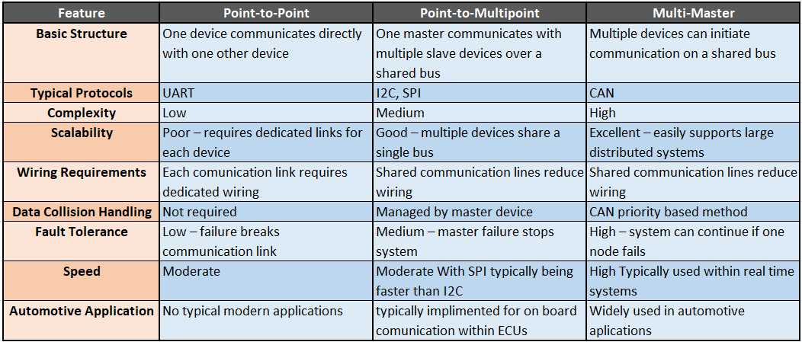

3 – System Design

3.1 – System Overview
The proposed system shown in Figure 1 is a packet based distributed network designed to control the lighting on the rear of an automobile. The circuit follows point-to-multipoint architecture, consisting of one master device and several slave devices. The master is responsible for managing the bus and generating transmission packets which are sent to slave devices.
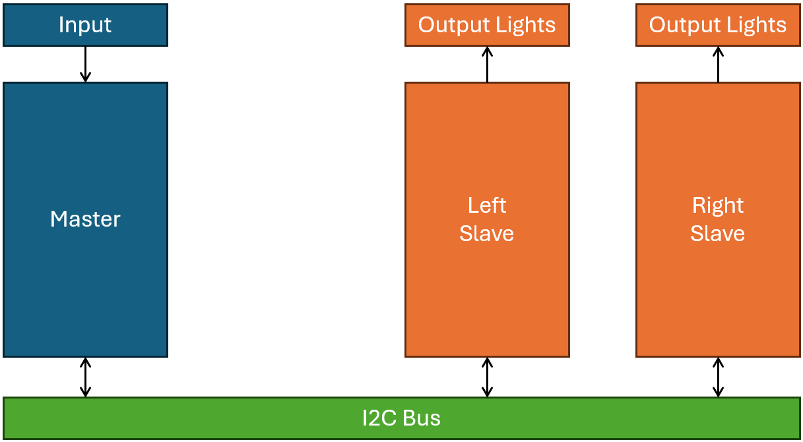
Figure 1 - System Block Diagram
A packet-based transmission approach allows for the implementation of several essential features such as slave addressing, larger data sizes and error detection, these features ensure correct and efficient operation. Each slave node is assigned to a specific side of the vehicle (Left and Right) and will only perform its task when the correct packet is received. This structured communication method is essential in an automotive application where expandability and deterministic behavior is essential.
The system was first designed and simulated in Proteus, enabling rapid development and verification of system functionality, then later implemented in the real world on a breadboard.

3.2 – Hardware Selection
In automotive applications CAN bus is primarily used, however due to simulation limitations in Proteus this is not an option. Due to this the I²C protocol was selected as it allows several different configurations including the point-to-multipoint architecture required for this system. SPI was considered for this system, however, was ultimately not used as its benefits of full-duplex transmission and higher data rates were unnecessary and would increase development complexity.
The Circuit makes use of PIC Microcontrollers for both master and slave devices. The chosen device is the PIC16F88, due to its widespread use, sufficient I/O and a dedicated I2C peripheral. Dedicated hardware helps to reduce software complexity and improve system performance.
Both Slave devices represent one corner of an automobile and have control over the following lights:
- Indicator (Left / Right) – Orange LED
- Brake Light – Red LED
- Reverse Light – White LED
Input signals to the master device are provided through buttons and switches, simulating driver inputs such as braking or indicating.
in Figure 2, the I2C bus is shown consisting of 3 microcontrollers, 2 * 10K pull-up resistors, necessary as I2C is an open drain bus and each connected device is only capable of pulling the bus low [12]. The final component is an I2C debugging terminal used to visualize each byte transmitted allowing for enhanced debugging during development.

3.3 – Proteus Implementation
The System was implemented in Proteus 9 making use of one master device and 2 slave devices. Shown in Figure 2 The master controller is placed on the left taking input from 6 switches; Ignition, Reverse, Hazards, Left indicator, Right indicator and Brake.
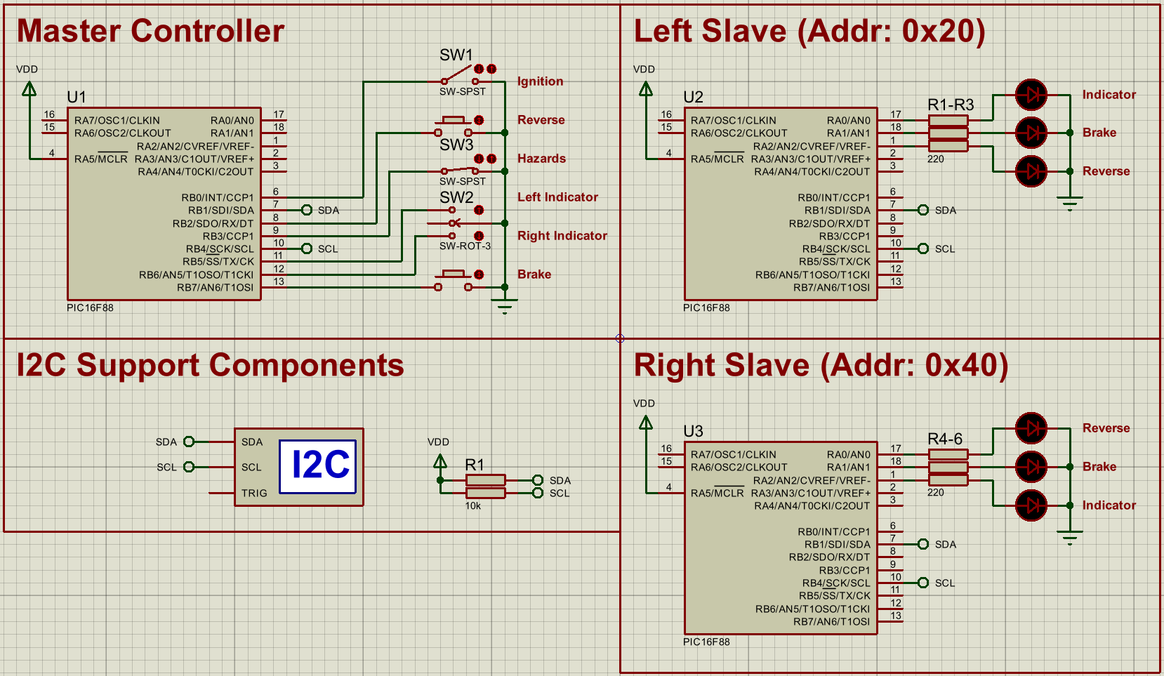
Figure 2 - Proteus Circuit Implementation

4 – Software Development

4.1 – Program Development Approach
The software for this system was developed in the C programming language making use of the CCS for PIC compiler as it is highly integrated with the Proteus simulation software. Three separate programs were developed, one for each microcontroller used. Software for both slave devices is functionally identical apart from the devices address as lighting functions are identical for both, this modular approach reduces development time, simplifies debugging, and improves the maintainability of the system.
As previously stated, communication between devices will use I²C, a custom packet structure as shown in Figure 3 was developed to improve system fault tolerance and expandability. The inclusion of a data length byte and CRC (Cyclic Redundancy Check) byte allows the receiver to ensure data integrity. A further benefit of this packet structure over a simple byte command approach is future expandability and modularity, as packet length is not fixed and can vary based on system requirements.
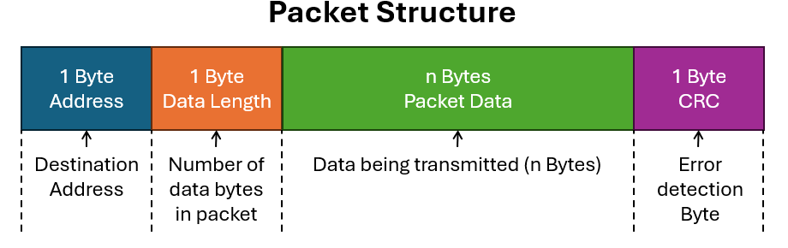
Figure 3 - Standard Packet Structure
In this system the first data byte of the packet indicates the sub system i.e. Engine, ABS or instrument cluster. Both rear lights have been assigned 0xF0, when this byte is received the slave device will know the packet is intended for itself. The second byte indicates the function within the specified module and are as shown in Table 2.
Table 2 - Sub System Function Bytes
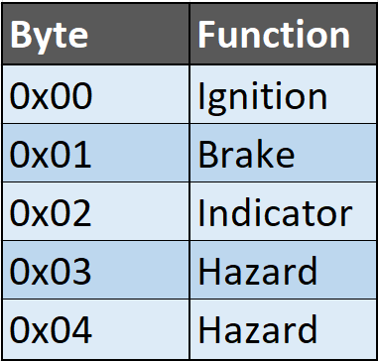
The third and final byte is the data for the selected sub system, for all functions implemented in this example only 0x00 and 0x01 are used where 0x00 means disable and 0x01 is enable.

4.2 – Master Program
The Master microcontroller is in control of all operations in the system, managing I²C communications and monitoring for user input. The operation of the master at a high level follows Figure 4.
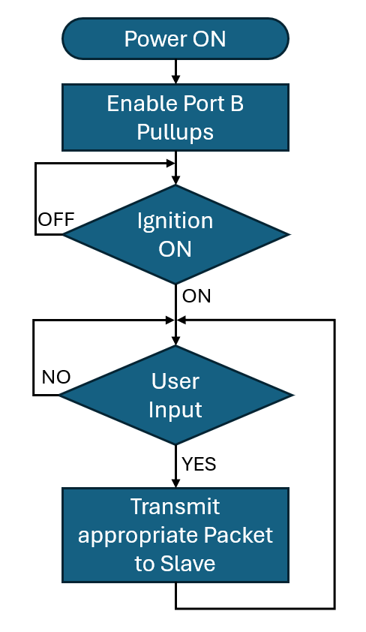
Figure 4 - Master High Level Operation
When Power is applied to the system the master configures port B as inputs and enables internal pull-up resistors as shown in Figure 5. This ensures inputs are in a known state, when a user actuates a button, this pulls low the input, and the master can react accordingly.
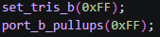
Figure 5 - Master Input Configuration
Once configured the master will not proceed further until the ignition input has been pulled low, emulating correct automotive functionality. When activated the master sets an internal ignition register allowing for the use of lighting functions and additionally transmits a packet to both slave devices informing them of the ignition status, as shown in Figure 6.
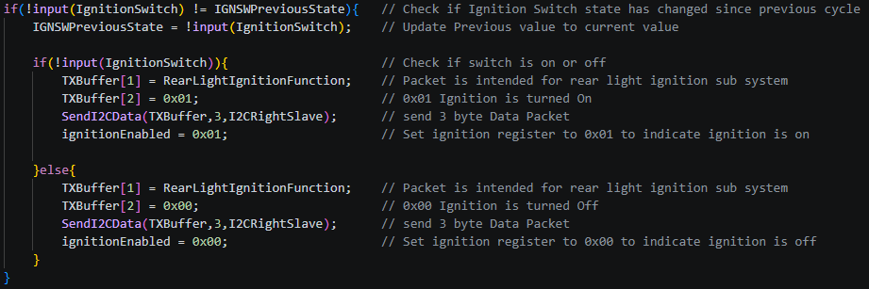
Figure 6 - Master Ignition Management
When the user actuates an input and the ignition is enabled, the appropriate packet is transmitted to the relevant slave device(s) (shown in Figure 7 ). The packets are sent on an event driven approach; this means that packets are only transmitted at a state change, this approach reduces unnecessary utilization, improving system efficiency and ensuring responsiveness of the bus as future devices are added.
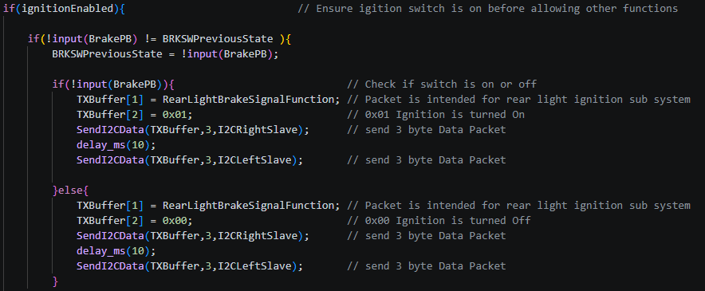
Figure 7 - Master User input Example (Brake Light)

4.3 – Slave Program
The operation of both slave devices follows Figure 8, When power is applied the microcontroller waits until a packet is received. Upon receiving a packet with the correct slave address an interrupt is triggered, interrupts are used to reduce the latency in responding to incoming packets as opposed to a polling method, this reduction in latency is critical for real-time operation in an automotive system.
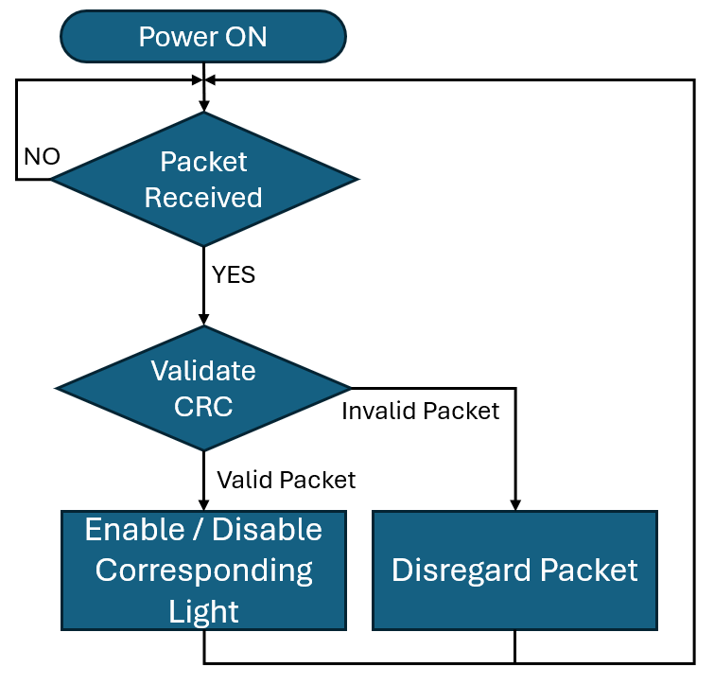
Figure 8 -Slave High Level Operation
The packet received can then be processed and decoded as shown in Figure 9, ensuring that the packet has been received correctly by checking the data length and calculating and comparing the CRC value. If a valid packet has been received it is passed on to further section, however if an invalid packet is received it is discarded to avoid unexpected behavior.
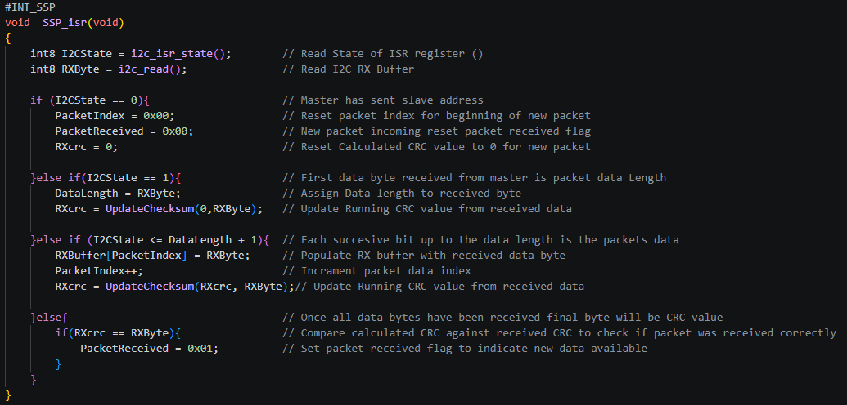
Figure 9 - Slave Received Packet Interrupt Routine
Based upon the received data the corresponding lighting outputs are controlled as shown in Figure 10.
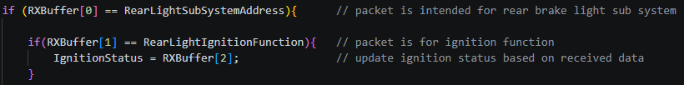
Figure 10 - Slave Output Control

4.4 – CRC Implementation
As the intended application for this system is in an automotive environment electrical noise is a large consideration for design as it can influence transmitted data causing unexpected behavior possibly leading to unsafe operation [13].
Commonly used is checksum bit, however this is not foolproof where certain faults will not be detected, such as cases where more than one bit has been flipped [14]. CRC improves this by performing mathematical function on the transmitted and received data and comparing results.
The algorithm used in this system is CRC-8, shown in Figure 11, this provides a good level of fault detection whilst still being calculated quickly enough to operate in real-time on low performance microcontrollers.
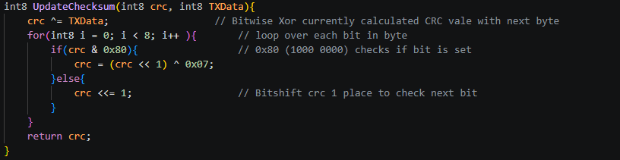
Figure 11 - CRC-8 Implementation

5 – Analysis and Evaluation

5.1 – System Performance evaluation

5.1.1 – Simulation
The system was initially tested via simulation in Proteus software. This allowed for the verification of both the hardware and software implementation in a controlled environment.
Testing was performed by actuating each input and observing for the correct output of the lights. The first function tested was the reverse lights and operated correctly as shown in Figure 12.
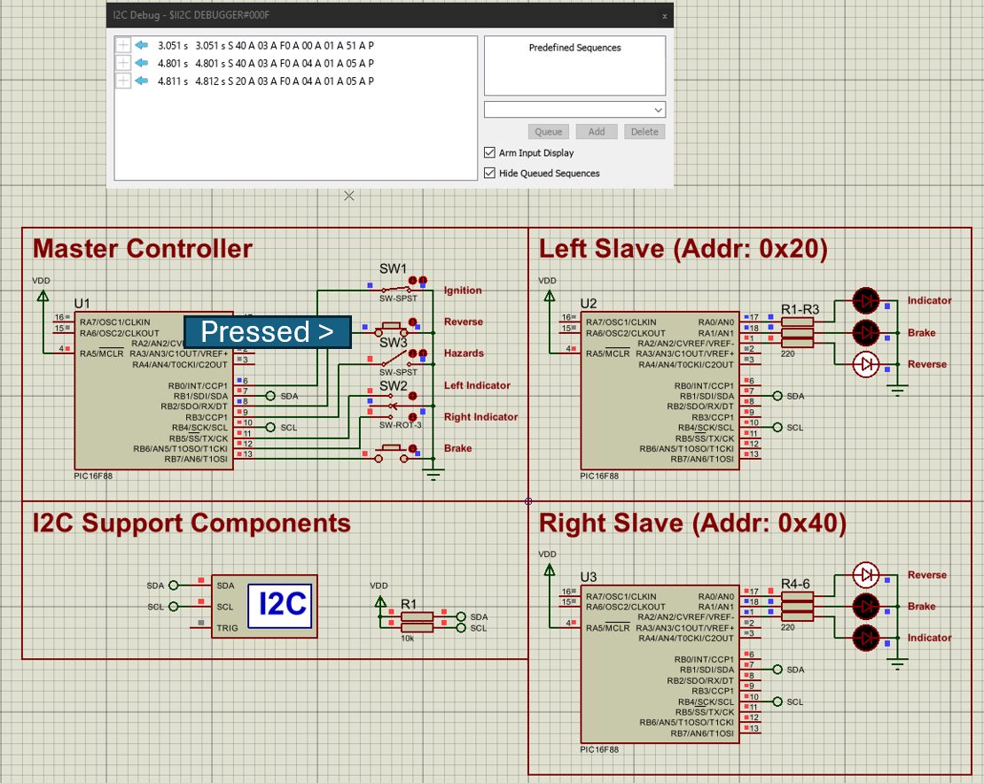
Figure 12 - Simulation testing Reverse lights
Further Testing was performed on all lighting Functions on all remaining functions, including Brake lights, hazard lights and indicators. In all cases the system responded correctly, demonstrating the correct operation of the implemented packet and event driven approach (See Appendix 1 – Full Simulation test Results).

5.1.2 – Breadboard
Following simulation further testing was performed by implementing the circuit on a breadboard to evaluate real-world performance. Unlike the simulation the system was exposed to external factors such as wiring inconsistencies and potential electrical interference.
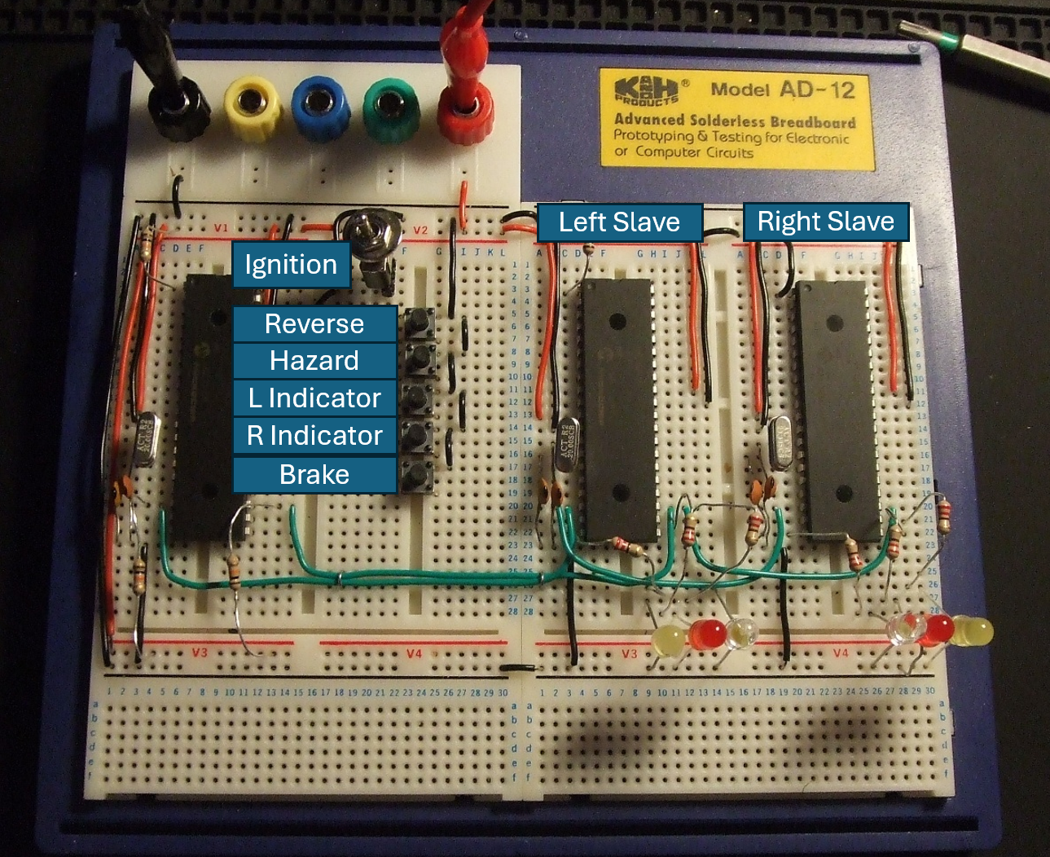
Figure 13 - Breadboard Implementation
As seen in Figure 14 and Appendix 2 – Full Breadboard Test Results, the correct system functionality was observed in the physical implementation across all user inputs. For functions with flashing lights such as the hazards the expected frequency of 1Hz is achieved. This is within the required range of 1-2Hz [15].
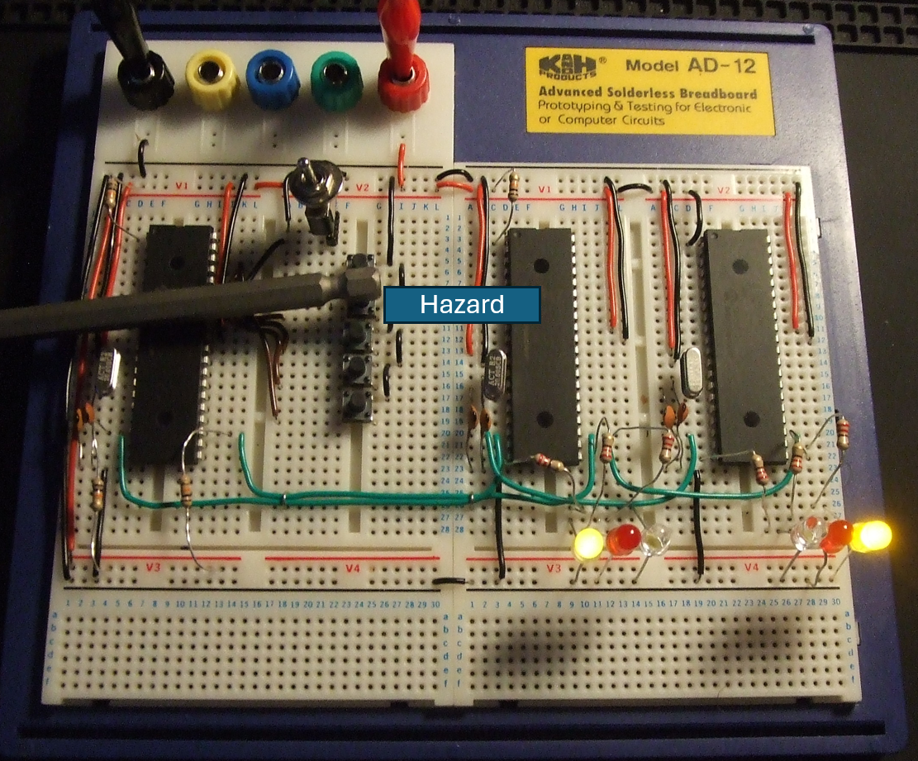
Figure 14 - Breadboard Testing hazard Lights

5.2 – System Limitations
Although the system behaved as expected, several possible drawbacks were identified. The use of point to multipoint architecture introduces a single point of failure; if the master device were to fail, communication of the entire network stops. This is a major disadvantage when compared to multi master architectures such as CAN bus; offering a significant improvement in fault tolerance.
Another limitation identified is the I²C bus, whilst being simple and effective to implement in smaller systems it is limited in scalability and speed. As additional devices are added, significant parasitic capacitance is introduced, affecting signal integrity and communication speeds [16]. Another drawback of I²C is the lack of a hardware method of reducing electrical interference; CAN bus implements a differential signal to significantly reduce interference.
The event driven approach, whilst improving efficiency on the communication bus may lead to data consistency issues, where if a packet is discarded or missed, the state on the slave device will be incorrect until another valid packet is received. This can be corrected by the slave sending an acknowledgment when a correct packet is received.

5.3 – Quality Management and Continuous improvement
To ensure the reliability and accuracy of the system, a structured testing and analysis approach was used. Development was done iteratively, with development beginning in simulation before progressing to physical implementation on breadboard, allowing for easier identification and correction of the software and hardware design.
Error handling through the incorporation of CRC, enables the detection of corrupted data and prevents unexpected system behavior. This is essential in a safety-critical application such as an automotive system, where incorrect behavior could lead to hazardous situations.
Continuous improvement was achieved throughout the development of the system by refining the packet structure, communication logic and fault detection to improve both system efficiency and reliability.

6 – Conclusion
This report has presented the design, implementation and analysis of a simple distributed control system used within an automotive setting. The system was able to successfully demonstrate reliable communication between a master device and several slave devices making use of the I²C bus and a packet-based communication implementing a structured data transmission, with addressing and error detection.
The use of an event driven communications approach helped to improve overall system efficiency by reducing unnecessary bus traffic. Implementing a Cyclic Redundancy Check enhanced system reliability by ensuring only valid data was processed. Results of both simulation and hardware testing demonstrated correct system behavior with both slave devices responding accurately to user inputs.
Despite positive results, several limitations were identified, including reliance on a single master device and scalability limitations of the I²C Bus. Future improvements could include switching to a multi-Master architecture such as CAN bus to increase fault tolerance and system robustness.
Overall, the system demonstrated how a distributed system can be implemented in an automotive environment to achieve reliability with the possibility of future system expansion.

References

[1] | D. S. a. D. P. Dawoud, Serial communication protocols and standards, River Publishers, 2022.
[2] | N. R. a. T. A. Laddha, "A review on serial communication," International journal of advanced research in computer science and software engineering, vol. 3, no. 1, 2013.
[3] | L. E. Frenzel, Handbook of serial communications interfaces: a comprehensive compendium of serial digital input/output (I/O) standards, Newnes, 2015.
[4] | L. E. Frenzel, Electronics explained: Fundamentals for Engineers, Technicians, and Makers, Newnes, 2010.
[5] | D. a. B. Y. a. D. M. a. L. M. Belkacemi, "Network on Chip and Parallel Computing in Embedded Systems," in 2016 IEEE 10th International Symposium on Embedded Multicore/Many-core Systems-on-Chip (MCSOC), Lyon, France, 2016.
[6] | J. a. H. S. Chen, "Analysis and Comparison of UART, SPI and I2C," in 2023 IEEE 2nd International Conference on Electrical Engineering, Big Data and Algorithms (EEBDA), Changchun, China, 2023.
[7] | J. Wu, "A Basic Guide to I2C," Texas Instruments, 2022.
[8] | F. Leens, "An introduction to I2C and SPI protocols," IEEE Instrumentation & Measurement Magazine, vol. 12, no. 1, pp. 8-13, 2009.
[9] | A. a. B. F. a. F. A. a. R. S. Bondavalli, "Master Failure Detection Protocol in Internal Synchronization Environment," IEEE Transactions on Instrumentation and Measurement, vol. 62, no. 1, pp. 4-12, 2013.
[10] | N. M. a. N. O. a. A. L. a. H. S. J. B. Ben Lakhal, "Controller area network reliability: overview of design challenges and safety related perspectives of future transportation systems," IET Intelligent Transport Systems, vol. 14, no. 13, pp. 1727-1739, 2020.
[11] | A. A. a. K. P. P. a. J. R. Salunkhe, "Design and implementation of CAN bus protocol for monitoring vehicle parameters," in 2016 IEEE International Conference on Recent Trends in Electronics, Information & Communication Technology (RTEICT), Bangalore, India, 2016.
[12] | S. Afzal, "I2C Primer: What is I2C? (Part 1)," Analog Devices, 2 9 2016. [Online]. Available: https://www.analog.com/en/resources/technical-articles/i2c-primer-what-is-i2c-part-1.html. [Accessed 5 5 2026].
[13] | H. a. D. R. a. P. S. Aysan, "Fault Tolerant Scheduling on Controller Area Network (CAN)," in 2010 13th IEEE International Symposium on Object/Component/Service-Oriented Real-Time Distributed Computing Workshops, Carmona, Spain , 2010.
[14] | T. C. a. K. P. J. Maxino, "The Effectiveness of Checksums for Embedded Control Networks," IEEE Transactions on Dependable and Secure Computing, vol. 6, no. 1, pp. 59-72, 2009.
[15] | GOV UK, "MOT inspection manual: cars and passenger vehicles," GOV UK, 1 4 2026. [Online]. Available: https://www.gov.uk/guidance/mot-inspection-manual-for-private-passenger-and-light-commercial-vehicles/4-lamps-reflectors-and-electrical-equipment. [Accessed 6 5 2026].
[16] | T. a. F. A. a. M. M. a. P. S. a. P. A. a. V. V. Addabbo, "Using the I2C bus to set up Long Range Wired Sensor and Actuator Networks in Smart Buildings," 2019 4th International Conference on Computing, Communications and Security (ICCCS), pp. 1-8, 2019.
[17] | M. Zibayiwa, "A Review on The Inter-Processor Communication: I2C, UART, and SPI interfacing techniques," 2021.

Appendix

Appendix 1 – Full Simulation test Results
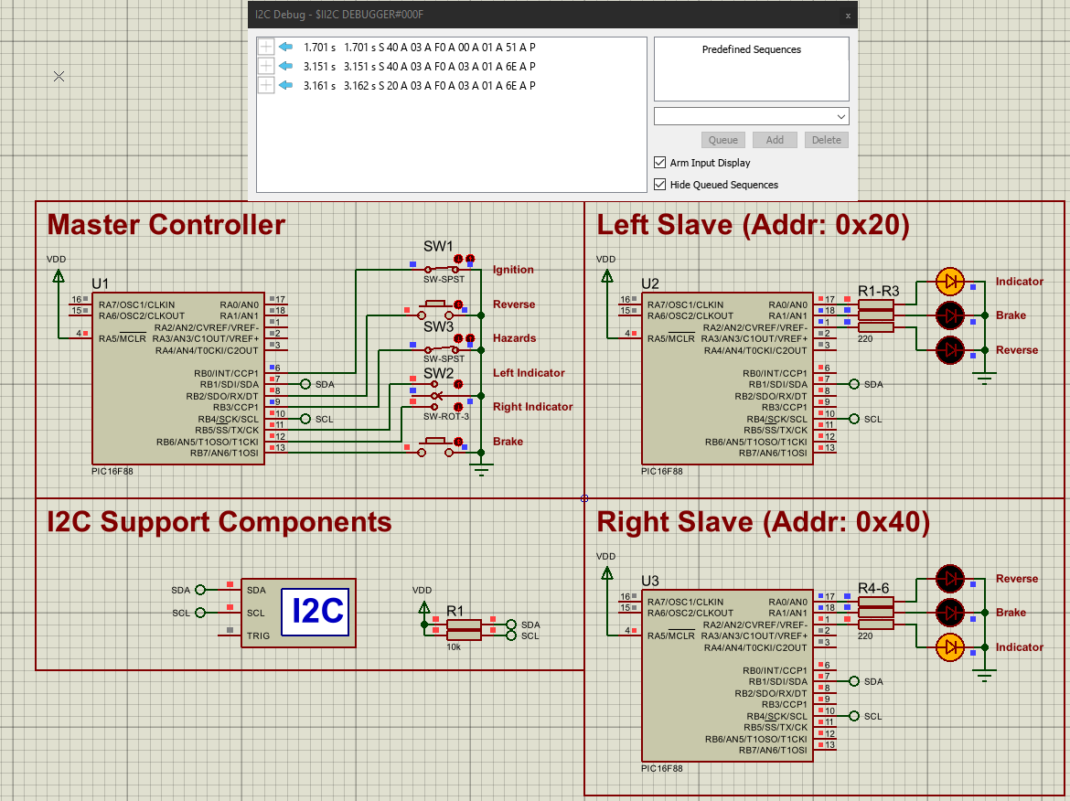
Figure 15 - Simulation testing Hazard lights
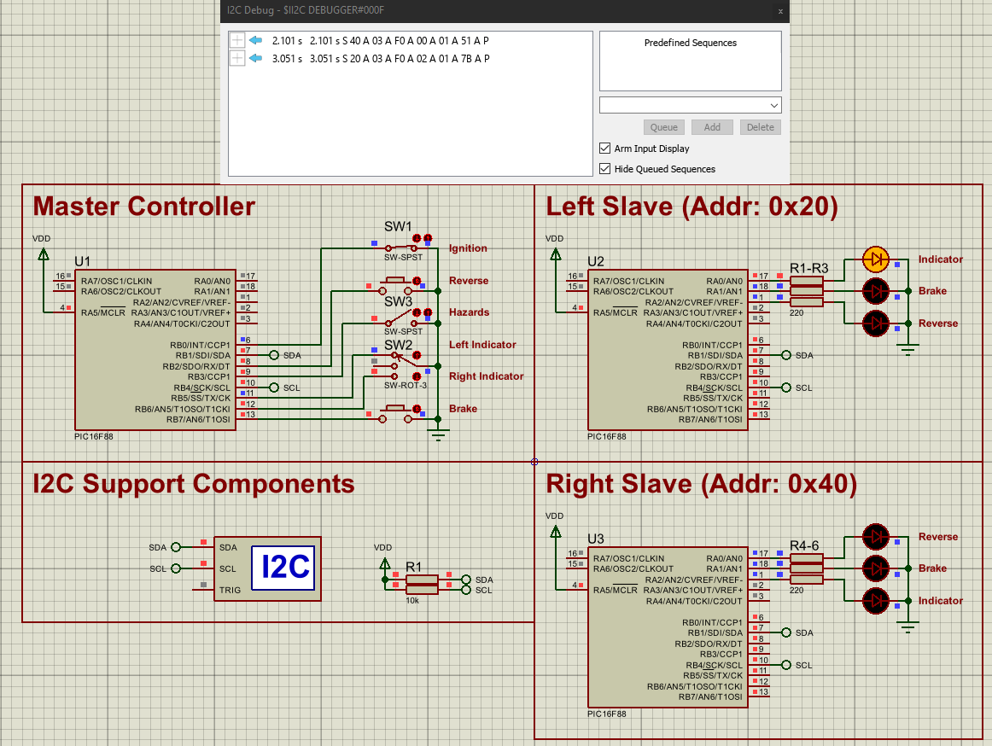
Figure 16 - Simulation testing Left Indicator light
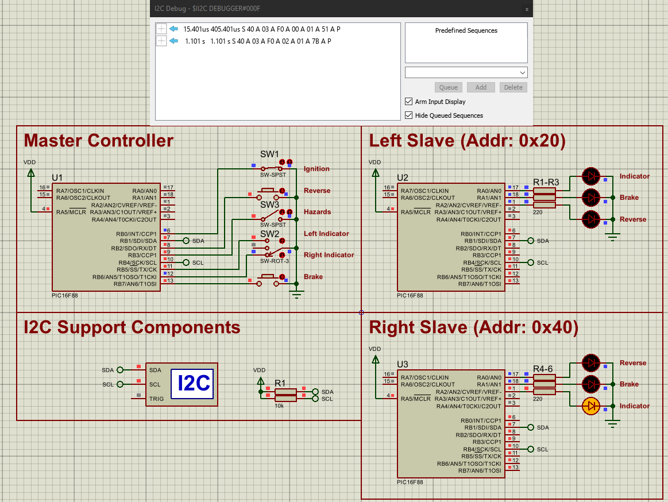
Figure 17 - Simulation Testing Right Indicator Light
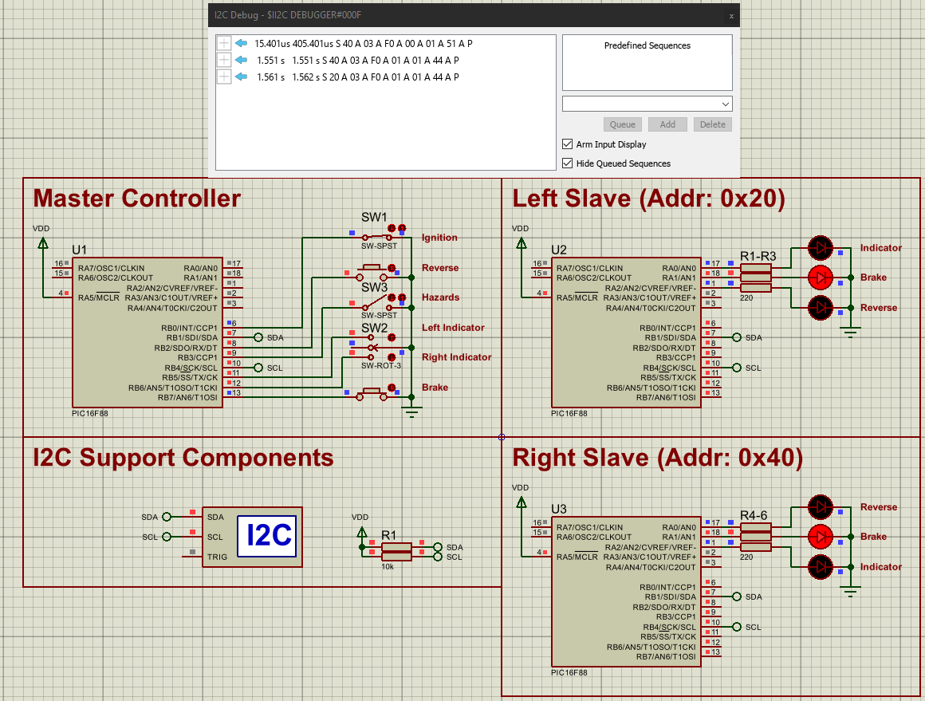
Figure 18 - Simulation Testing Brake Lights

Appendix 2 – Full Breadboard Test Results
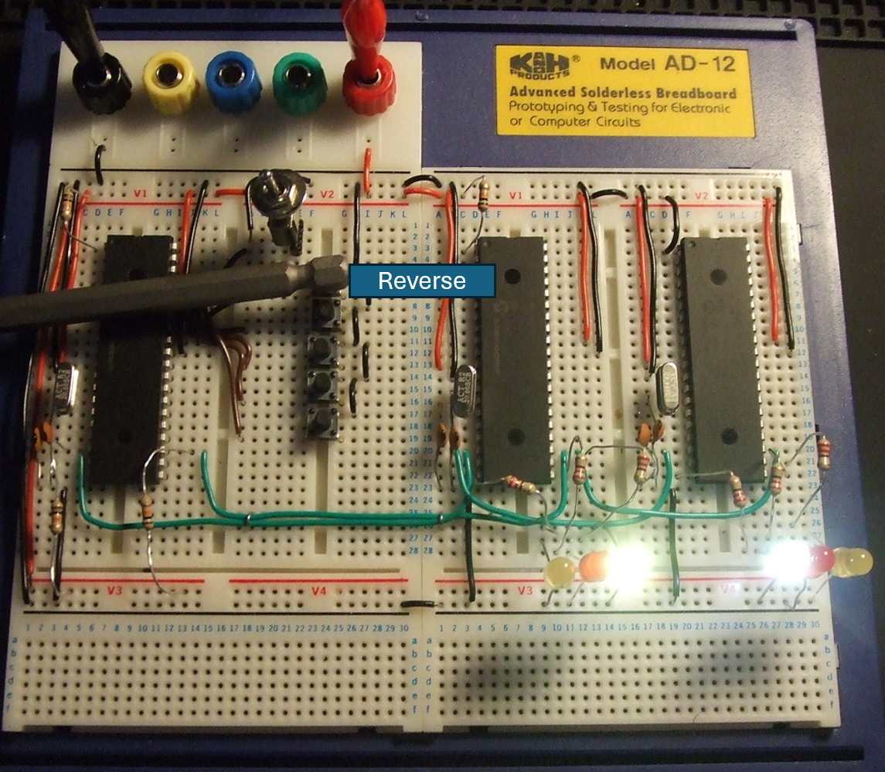
Figure 19 - Breadboard Testing Reverse Lights
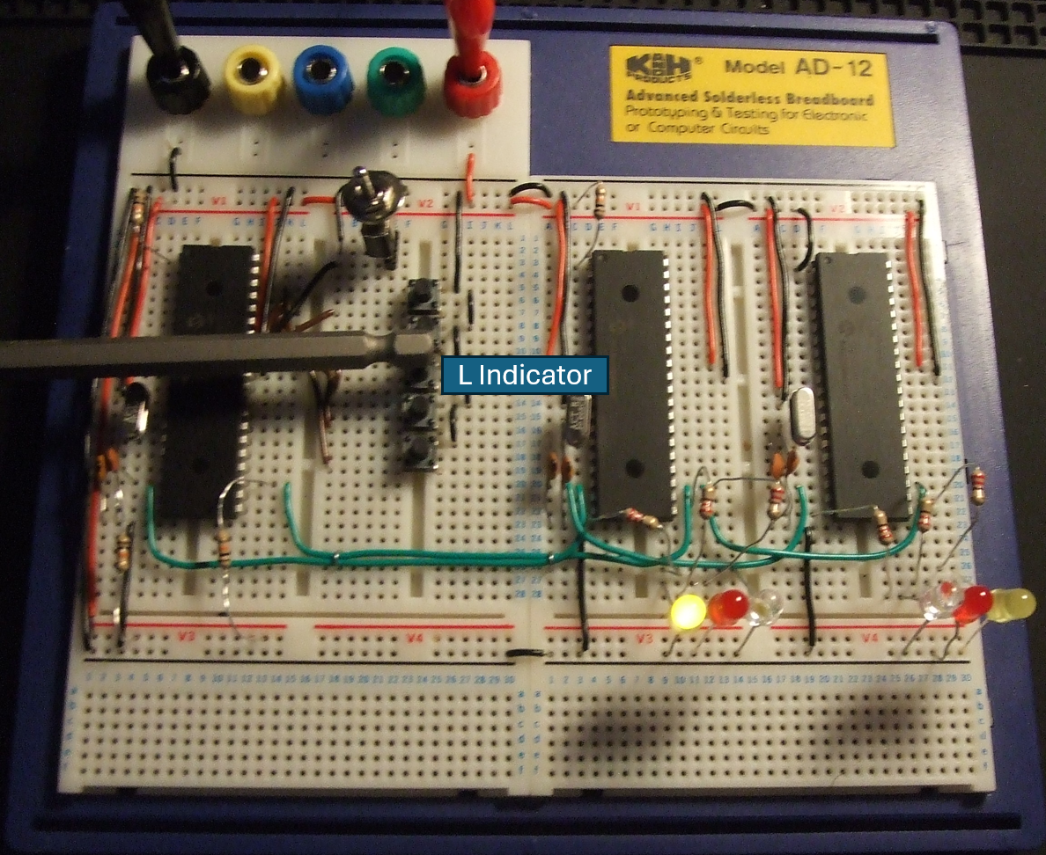
Figure 20 - Breadboard Testing Left Indicator Light
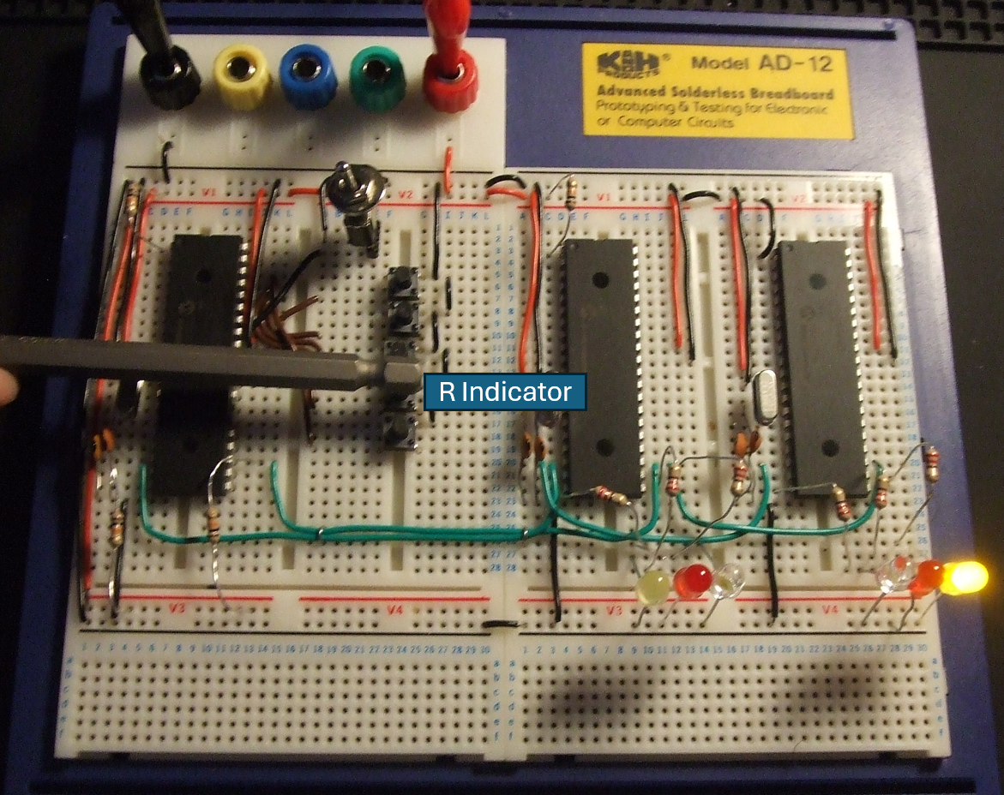
Figure 21 - Breadboard Testing Right Indicator Light
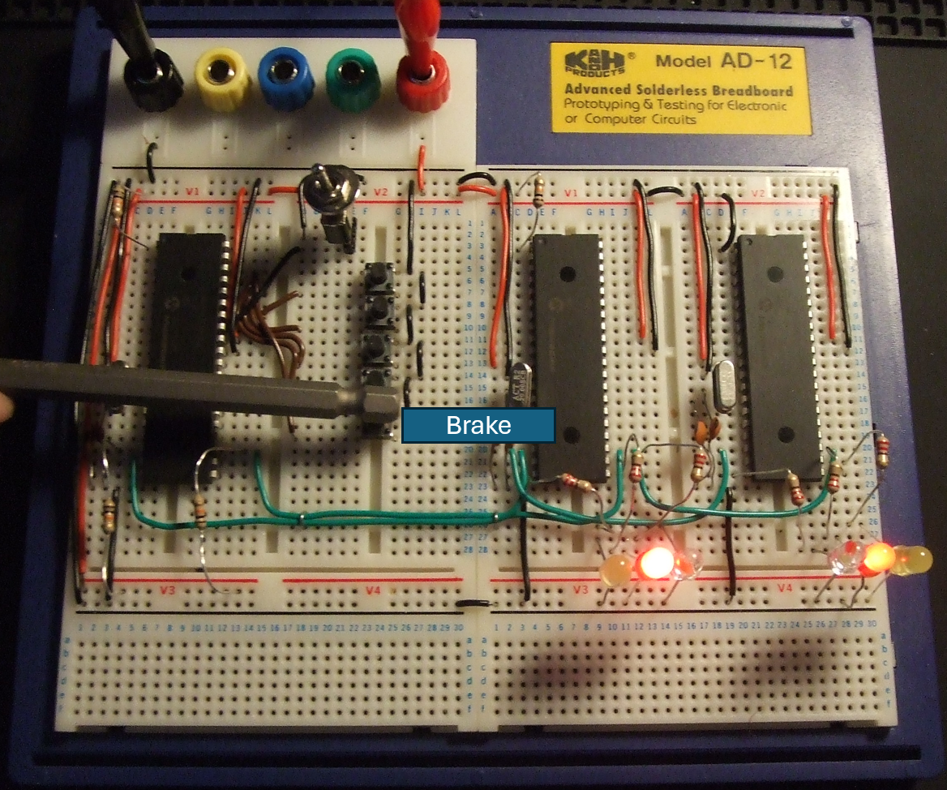
Figure 22 - Breadboard Testing Brake Lights

Appendix 3 – Pic Programming Setup
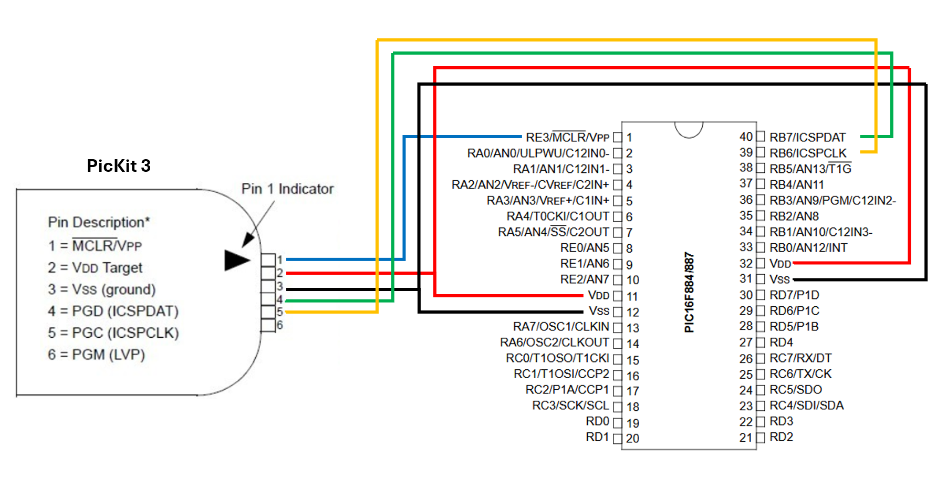
Figure 23 - Pic Programming Setup

