

Module Name: Human Capital Management
Module Code: LCMB7023
Assessment Title: The influence of national and international labour markets on HRM and IHRM strategies
Lecturer’s name: Dr Gladius Kulothungan

Student Name: Nurul Hasan
Student ID: 2509169

Word count: 2584
Date of Submission: 13ᵗʰ November 2025

Term 1

Executive Summary
The report compares the changing trends in the global labour market, specifically, in the textile industry, in terms of Human Resource Management (HRM) and International HRM (IHRM). The analysis is used to note how the dynamism in technology, particularly automation, AI and the gig economy are transforming job configurations, and forcing HR to shift to a more strategic data-oriented role. The ageing of the population, migrations and the global crisis led to further issues of workforce planning and compliance and demand ethically-based adaptive HR strategies. The extensive skills scarcity issues that are faced in the world today clearly reflect the necessity to have strategic human resource management strategies like the build, buy, borrow, and bind models that help fill capability gaps. The reflective part of the paper is structured by putting the reflective cycle by Gibbs and discusses the personal development of five areas of critical capability: technology, communication, teamwork, leadership, and self-directed learning. The strengths were found in the areas of communication and adaptability whereas the areas to be improved were conflict management and proficiency in HR analytics. The action plan consists of a series of specific measures like passing analytics qualifications, managing multicultural projects, participating in life-long learning, etc., to improve the preparation to work in global human resources concerning the international textile labour market. Generally, the report is composed of theory, evidence, and reflection to provide practical ideas on how sustainable HR effectiveness can be deployed in an interconnected world.

Table of Contents
Introduction 4
1. Technological Advancements and Implications for HRM and IHRM 5
1.1 The Transforming of Labour Markets 5
1.2 Implications for HRM/IHRM Strategies 6
2. Demographic and Geopolitical Factors Influencing Employment Markets 7
2.1 Major Demographic Factors 7
2.2 Major Geopolitical Drivers 8
2.3 Challenges Facing HR Professionals 8
3. Addressing Persistent Skills Gaps and Talent Shortages through Strategic HRM 10
3.1 Grasping the Root Causes 10
3.2 Strategic HRM Strategies: The Make, Buy, and Borrow Framework 10
3.3 Sector-Specific Application 12
4. Reflective Account on Competencies in a Global HR Environment. 13
4.1 Textile Industry Context 13
4.2 Self-Assessment and Evaluation 13
Conclusion 16
References 17
Appendix 20

Introduction
The contemporary world of business is unmatched in the degree of turbulence, rapid technological disruption and complexity of interconnection that leaves a marked imprint in the labour markets (OECD, 2023). They are external factors that compel Human Resource Management (HRM) to change strategically such that this necessitated a change in which the Human Resource Management was extensively engaged in transactional activities to a role where it became the Strategic Partner and Change Agent. This report drastically looks at the nature of the labour market change brought about by technology, demographic and geopolitical trends and its immediate impact on the HRM and International HRM (IHRM) strategies. It culminates with a self-analysis and it is through this academic theory that I am able to thrive in this adaptive professional world.

1. Technological Advancements and Implications for HRM and IHRM
The modern labour market is experiencing an ever-changing earthquake of technological innovations and swept the Human Resources (HR) strategy and the labour market (OECD, 2023). This change is mostly characterized by the simultaneous influence of Automation, AI (Brynjolfsson, 2022) and the Gig Economy.

1.1 The Transforming of Labour Markets
The processes of manufacturing and services are being automated and their AI replacing traditional and routine-focused jobs (Frey and Osborne, 2017). This loss of jobs is, nevertheless, flagrantly counterbalanced with "job gain" creation of absolutely new occupations in the spheres of AI ethics, cybersecurity, and maintenance of a robot (Brynjolfsson, 2022). It is creating ubiquitous Skills Churn, which is swiftly reducing the half -life of acquired skills and thereby making a larger share of digital, STEM, and literacy-oriented competencies more required (Becker, 1993).
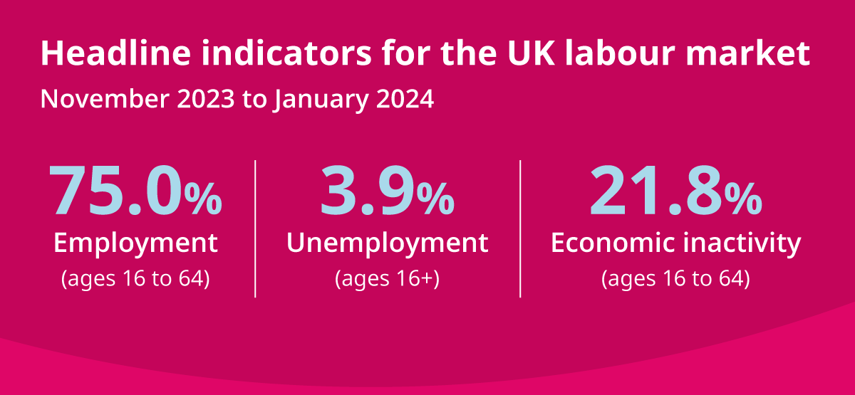
Figure 1 UK labour market transformation; Source: (Office for National Statistics (ONS), 2024)
At the same time, the Gig Economy, which is supported by digital platforms, is hastening the transition to full-time employment to flexible and contract-based labour. Although this change provides flexibility to businesses, as well as to so-called Digital Nomads, it generates a high level of ambiguity as far as the classification of workers (employees vs. independent contractors) are concerned. Such an ambiguity confronts the history of labour protection, employment rights, and job security (ILO, 2021; Schwab, 2017).

1.2 Implications for HRM/IHRM Strategies
Such shifts in the market require the HR to shift its perception to a Change Agent by pivoting the HR contributions of a transactional to a strategic undertaking (HCM Functions).
- Talent Acquisition and Strategic Hr Planning: Technology has transformed the talent acquisition buy approach. With E-Recruitment system, Applicant Tracking Systems (ATS), it increases efficiency and increases the talent worldwide search (Holm, 2012). To be more strategic, Data Analytics and AI can shift Human Resource Planning (HRP) to be a proactive tool, with which one can predict future human skills requirements and the likelihood of attrition (Marler and Boudreau, 2017). The HR has to deal with a blended workforce (gig, part-time, full-time), so it needs flexible policies to maintain balance between productivity and engagement of the workers (Deloitte, 2023).
- Learning & Development (L&D): Continuous upskilling and reskilling as a requirement to solve the skills gap has become critical. L&D approaches should change to include micro-learning, online badges, and AI that can develop individual learning journeys and make workers more employable and adaptable to work (World Bank, 2023).
- IHRM Facts and Compliance: In the case of International HRM (IHRM), a digital platform can be used to manage an off-site workforce globally. This however opens up the role to convoluted international laws. IHRM has to work between the labour laws of different countries, and they are required to comply with stringent data protection standards in regimes such as the General Data Protection Regulation (GDPR) especially when it comes to the sensitive data of the multinational workforce. Moreover, the HR practitioners should address the ethical risk of Bias in the AI models deployed in the fields of hiring and retention, that is, fairness and transparency are to be ensured in the global aspects of operations (Binns, 2018).

2. Demographic and Geopolitical Factors Influencing Employment Markets
The contemporary employment markets are acutely influenced by the macro-environmental factors that present systemic risk as well as complexities to inflict opportunities to the Human Resource (HR) functions. The forces cannot be controlled by the firm itself, requiring a strategic flexibility (Sparrow et al., 2016).

2.1 Major Demographic Factors
The main demographic issue that the developed economies are confronting is the fact of Ageing Populations (BIS, 2022). The outcome of this trend is a declining rate of workforce participation, high dependency ratios, and extreme risks of knowledge transfer as older and experienced workers retire (Brewster et al., 2016). HR needs to take the initiative to employ multi-generational workforce tactics aimed at retaining talent (the older ones) and establishing a phased retirement scheme.
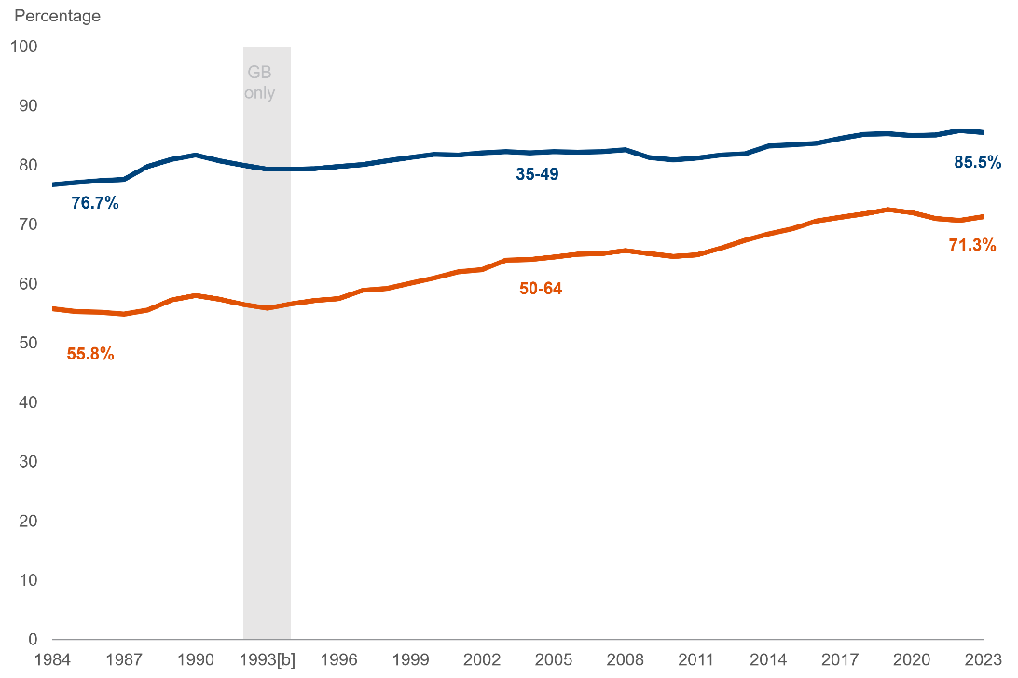
Figure 2 Economic labour market status in UK; Source: (GOV.UK, 2023)
At the same time, Shifting Migration Trends are a bit more of a problem. When migration is done at a high level, migration may result in brain gain to the recipient countries, assist in addressing acute skills shortages (technical and professional). On the other hand, it leads to brain drain in countries of origin (Cerna, 2016). It is strongly influenced by the restrictive Immigration Policies that, in turn, directly affect the availability of talent in such areas as healthcare and hospitality. Moreover, it will be necessary to raise the Workforce Diversity, meaning that organizations should focus on to have solid policies of Diversity, Equity and Inclusion (DEI) to address the dynamic aspects of diversity within work teams, as well as cultural integration and pay equity (Bersin, 2023).

2.2 Major Geopolitical Drivers
Internationalization of employment business brings about instability in the global labour markets:
- Trade Wars and Protectionism: Geopolitical tension, which is talked about by Dicken (2015), may cause Trade Wars and Protectionism and disruptive global supply chains. This compels the Multinational Corporations (MNCs) to quickly change the recruitment destinations and approaches to reduce the tariffs and sourcing risks.
- Political Instability and Sanctions: Political instability in the areas of operation is a direct cause of Expat Risk. IHRM has to address intricate matters that occur in international assignments such as negotiating safety measures, implementing the legal transfer of payroll through authorized boundaries and sustaining businesses (Sparrow et al., 2016).
- Pandemics & Global Health Crises: The recent pandemic-induced crises have provided a catalyst to the digital transformation, which has made Remote Work and Digital Transformation a new reality of operations (Harvard Business Review, 2023). This demands the HR to immediately introduce new health and safety strategies and promote business continuity planning as one of the core strategies (McKinsey, 2021).

2.3 Current Challenges
The aging populations, youth unemployment and political instability among the nations have led to segregation of the global labour market. Migration limits and employment replacement that comes with automation have aggravated skills shortage (Isiaku and Adalier, 2024).

2.3 How the Challenges affect HR Professionals
Combinability of these factors presents HR with three core issues:
- Compliance: HR workers have to be in profound knowledge of a constantly shifting landscape of domestic and global employment regulation (Sparrow et al., 2016). Lack of compliance in various jurisdictions is life-threatening due to legal and reputational damages.
- Risk Management and Duty of Care: Due to the increase in the global workforce, it is essential to develop a solid crisis management and duty of care process to all employees and, in particular, those who arrive as an Expatriate Workforce (Brookfield, 2021).
- Talent Mobility and Cultural Integration: HR needs to be able to navigate the logistics of Talent Mobility that involves dealing with complicated visa, work permit, and taxation laws (Cerna, 2016). Moreover, the inability to successfully manage diverse and decentralized workforces, and especially the involvement of those working under Offshoring and Outsourcing Practices, implies the necessity of elaborated cross-cultural communication and Cultural Integration strategies to ensure the productivity of the work performed in new time zones and cultures (Dicken, 2015).
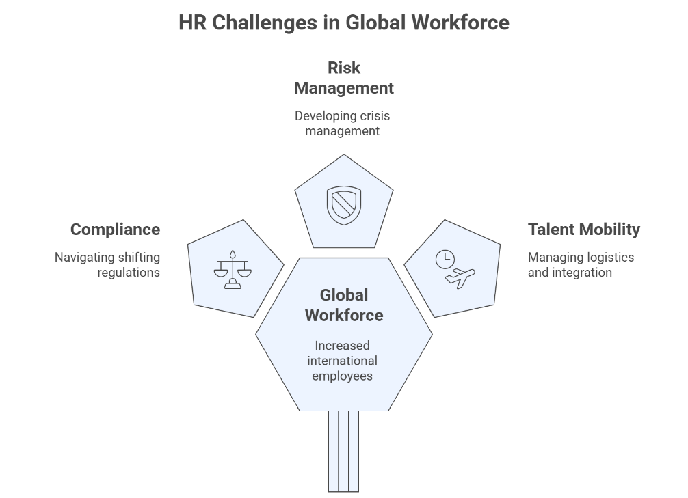
Figure 3 Challenges Facing HR Professionals; Source: Author

3. Addressing Persistent Skills Gaps and Talent Shortages through Strategic HRM
The endemic skills gaps and talent deficiencies in the key sectors are direct responses to the overwhelming Skills Churn fuelled by the technology, structural dis-alignment of the education sector to the industry needs and the failure of corporations to invest in Learning and Development (L&D) (Becker, 1993).

3.1 Grasping the Root Causes
The inherent reason behind the systematic skill shortages is the accelerating rate of technological change, which ensures that as new job positions appear, the old education system is unable to supply talent adequately in order to cope with the demand that is specialized. Such a misalignment dictates the need to change an approach towards maintaining headcount to managing capabilities in a strategic manner. HRP starts with Forecasting Demand and Supply and a stringent Gap Analysis to measure the lack and its strategic effect (Reilly and Williams, 2016).
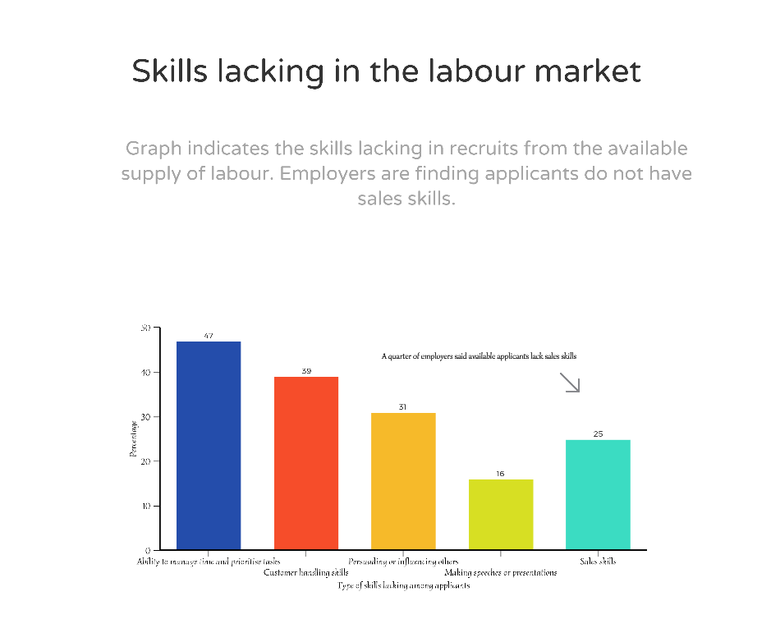
Figure 4 Skills Gaps in the labour market; Source: (Agency Central, 2022)

3.2 Strategic HRM Strategies: The Make, Buy, and Borrow Framework
Organisations should pursue blended approach to bridging the skills gap, commonly as the Make vs. Buy decision and can be paralleled into Borrow and Bind approach (Atkinson, 1984):
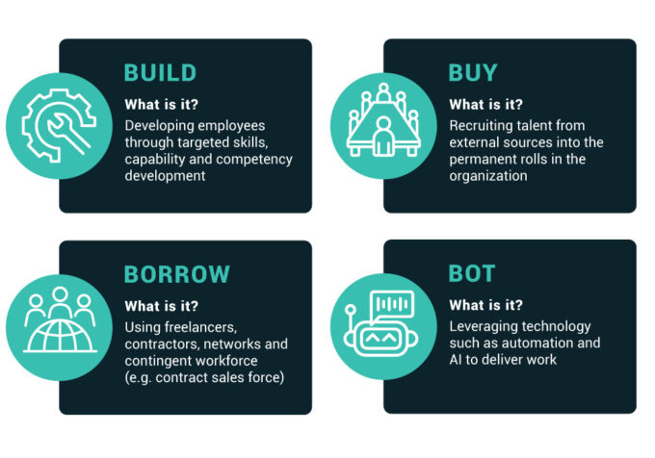
Figure 5 Strategic HRM Framework: 4B Model; Source: (IMD Business School, 2024)
- "Build" Strategies (Internal Development): In this strategy, the company focuses on the upside of L&D (Noe et al., 2017).
Action: Making mandatory upskilling courses, building corporate academies, or creating strategic alliances with universities of ed-tech companies. This will guarantee that current employees are reskilled to new jobs, and a culture of constant learning (Google HRP Strategy) and maximization of the current human capital will be realized (Becker, 1993).
- “Buy” strategies (External Acquisition): This is aimed at sourcing out new talent that is rare in the external labour market.
Action: An action based on adopting the future sources of talents using advanced talent analytics (Marler and Boudreau, 2017) to predict, improve the employer brand by becoming an employer of choice (Armstrong and Taylor, 2020), and offering competitive remuneration packages to attract highly demanded expertise.
- “Borrow" Strategies (Leveraging Outside Talent): This is the immediate short term skill shortage that the company utilizes external sources to overcome the short-term difficulties.
Action: Hiring consultants, hiring freelancers or contracting talent on the internet on short-term projects. This taps into the Gig Economy to get immediate access to niche skills, like freelance AI professionals, without a permanent commitment.
- "Bind" Strategies (Retention): This is the most important strategy of retaining the talent pool that the organization has already invested in.
Action: Developing interesting career paths, introducing job rotation schemes and mentorship schemes, and ensuring the high level of the workforce satisfaction due to flexible work schemes (The HRP Strategy of Google).

3.3 Sector-Specific Application
Healthcare
With chronic nurse and physician shortages (Brookfield, 2021), this industry is significantly dependent on “Buy” strategies by conducting intensive cross-border recruitment frequently involving brain gain to the country of receipt. For example, Bupa UK rely heavily on Buy strategies. At the same time, the strategies of "Bind" are operationalized through better working conditions and effective career progression to avoid high turnover.
Tech
In cases where the human skills such as cloud computing and AI have rapid perishability, ‘Build’ strategies (in-house coding bootcamps) are vital. They are also very popular because of the urgent project requirements. BT Group, IBM, and Arm Holdings adopt Build strategies.
Hospitality
In a competitive labour market, the industry frequently resorts to so-called Build (in-house management development programs) techniques of training the vital leadership and customers care skills, with the employer image reaffirmation concomitantly promoted to purchase entry-level talent.

4. Reflective Account on Competencies in international Labour Market (Textile sector)

4.1 Textile Industry Context
International textile labour market is a competitive global economic industry that is being highly technological with changing supply chains and varying cultural labour forces (Office for National Statistics, 2025). It is under a constant pressure to maintain cost, ethical labour, and sustainability. Human resource management is critical towards ensuring workforce flexibility, adherence, and productivity in the international operations (Stewart and Brown, 2019).

4.2 Self-Assessment and Evaluation
Systematic Model of the Process of Reflection fibres Reflective Cycle by Gibbs (1988) is a model that involves six steps namely description, feelings, evaluation, analysis, conclusion and plan of action. I shall apply this model to reflect on my experience in learning abroad and acquiring experience as a professional, with a particular emphasis on the course of acting as a Human Resource (HR) professional who is working on the global clothing labour market.
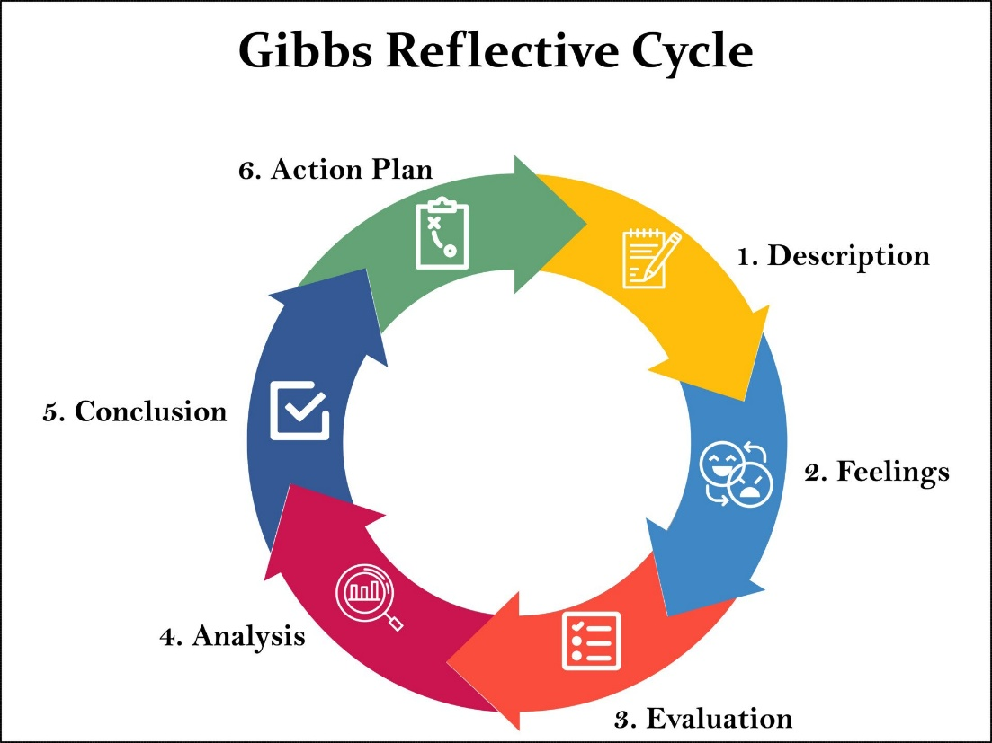
Figure 6 Reflective Cycle by Gibbs; Source: (Gibbs, 1988)

Description
Some of the international projects that I undertook during this term in my MBA course, as a group project, were global HRM and a presentation on cross-cultural labour relations in the textile industry. Microsoft Teams, Google Workspace, and AI-based applications like ChatGPT were necessary to perform these tasks and collect and synthesize data.
Feelings
Initially, I was self-confident in terms of task handling together with some anxiety concentrating on the collaboration with culturally different classmates. The initial misunderstanding was brought about by the lack of familiarity of new technologies and differentiated communication styles. Nevertheless, over time, I gained the courage to be more self-confident because I got used to virtual collaboration tools and understood how to value cultural diversity.
Evaluation
This experience enabled me to realize my core asset in terms of capabilities to communicate and self-direction capabilities. When it came to the field of collusion and cooperation even during a busy time, the good peer responses included that I could communicate effectively and keep working alongside my team in a stressful situation. The fact that I dedicated my life to lifelong learning helped me look beyond what was in the course materials to determine what was in global labour dynamics.
Analysis
HR professionals have to deal with diversity and adopt technology to enhance the efficiency of the workforce in global textile market. I currently possess these requirements, but I understand that I still have to improve my analytical and leadership capabilities. The complexity of the textile industry, which is manifested in the global supply chains, labour rights concerns, and so on, necessitates HR professionals who would be able to make evidence-based and inclusive decisions and uphold ethical standards at the same time.
Conclusion
Looking back at my learning experience, I understand that my skills to communicate smoothly, adjust fast, and study on my own are a strong base to the professional development. Nevertheless, to progress within the global HR sector, I need to improve my conflict management skills, leadership, and digital analytical skills.
Action Plan
Objective | Action | Evidence of Progress | Resources Needed | Timeline
Enhance HR analytics and digital proficiency | Complete an online certification in HR Analytics using Power BI and Excel | Course completion certificate | Coursera subscription; laptop with updated software | By Feb 2026
Strengthen intercultural conflict management | Volunteer to MBA group project; seek 360° peer feedback | Peer evaluation reports; reflective journal entries on group experience | Guidance from course mentor; intercultural communication workshops | By March 2026
Develop self-directed learning discipline | Allocate two hours weekly for professional reading on global labour trends and ethical HR | Reading log; applied insights in class discussions | Access to academic journals and HR publications | Ongoing, weekly

Conclusion
The discussion shows the world labour dynamics is being disrupted by technological disruption, demographic changes, and geopolitical instability. HR professionals are expected to change their functions into strategic allies, with the help of analytics, lifelong learning, and dynamic planning of work force. The incorporation of the “build–buy–borrow–bind” strategies are critical to the elimination of skills gaps and the challenge of remaining competitive. Finally, organizations need to adapt, use data, and make ethical decisions that support organizational resilience in the global environment that is becoming more uncertain regarding employment issues.

References
Agency Central. (2022). Everything You Need to Know About the UK Sales Skills Shortage. [online] Available at: https://www.agencycentral.co.uk/articles/everything-you-need-to-know-about-the-uk-sales-skills-shortage
Armstrong, M., & Taylor, S. (2020). 'Armstrong's Handbook of Human Resource Management Practice' (15th ed.). Kogan Page.
Atkinson, J. (1984) 'Manpower strategies for flexible organizations', Personnel Management, 16(8), pp. 28-31.
Becker, G. S. (1993) Human capital: A theoretical and empirical analysis, with special reference to education. Chicago: University of Chicago Press.
Bersin, J. (2023) 'Diversity, equity, and inclusion trends in the workplace'. New York: Wiley.
Binns, R. (2018). 'Fairness in Machine Learning: Lessons from Political Philosophy'.
BIS (2022) Workforce diversity and economic inclusion. London: UK Government.
Brewster, C., Chung, C. and Sparrow, P. (2016) Globalizing human resource management. London: Routledge.
Brookfield (2021) Global mobility trends survey report.
Brynjolfsson, E. (2022) 'The AI-driven economy: Preparing for the workforce of the future'. Cambridge: MIT Press.
Cerna, L. (2016) 'The impact of high-skilled migration on the labor market', Migration Studies, 4(2), pp. 145-163.
Deloitte (2023) 'The future of work: Agility and digital transformation'. London: Deloitte Insights.
Dicken, P. (2015) Global shift: Mapping the changing contours of the world economy. London: Sage.
Frey, C. B. and Osborne, M. A. (2017) 'The future of employment: How susceptible are jobs to computerization?', Technological Forecasting and Social Change, 114, pp. 254-280.
Gibbs, G. (1988) Learning by Doing: A guide to teaching and learning methods. Further Education Unit, Oxford Brookes University, Oxford
GOV.UK. (2023). Economic labour market status of individuals aged 50 and over, trends over time: September 2023. [online] Available at: https://www.gov.uk/government/statistics/economic-labour-market-status-of-individuals-aged-50-and-over-trends-over-time-september-2023/economic-labour-market-status-of-individuals-aged-50-and-over-trends-over-time-september-2023
Harvard Business Review (2023) 'Navigating the hybrid work revolution'. Boston: Harvard Business School Press.
Holm, A. B. (2012). 'E-recruitment: Towards a Ubiquitous Recruitment Process'.
ILO (2021) World employment and social outlook. Geneva: International Labour Organization.
IMD Business School (2024). The 4b talent framework - Management trends - CHRO I by IMD. [online] IMD business school for management and leadership courses. Available at: https://www.imd.org/ibyimd/human-resources/five-trends-that-are-reshaping-the-four-bs/
Marler, J. H., & Boudreau, J. W. (2017). 'An Evidence-Based Review of HR Analytics'.
McKinsey (2021) 'The future of work after COVID-19'. New York: McKinsey & Company.
Noe, R. A., Hollenbeck, J. R., Gerhart, B., & Wright, P. M. (2017). 'Fundamentals of Human Resource Management' (7th ed.). McGraw-Hill Education.
OECD (2023) 'Employment outlook 2023: Future trends in global labor markets'. Paris: OECD Publishing.
Office for National Statistics (2025). Labour market overview, UK. Available at: https://www.ons.gov.uk/employmentandlabourmarket/peopleinwork/employmentande mployeetypes/bulletins/uklabourmarket/May2025 (Accessed: 1 Novemer 2025).
Office for National Statistics (ONS) (2024). UK labour market for November 2023 to January 2024. [online] T.co. Available at: https://t.co/F9TC4bkR4d [Accessed 2 Nov. 2025].
Reilly, P., & Williams, T. (2016). 'Strategic HR: Building the Capability to Deliver'. Gower Publishing.
Schwab, K. (2017) 'The fourth industrial revolution'. Geneva: World Economic Forum.
Sparrow, P., Brewster, C. and Chung, C. (2016) Globalizing human resource management. London: Routledge.
Stewart, G.L. and Brown, K.G., 2019. Human resource management. John Wiley & Sons.
World Bank (2023) 'The role of micro-credentials in future employment'. Washington, DC: World Bank.

Appendix
SWOT Analysis
SWOT Category | Details
Strengths | - Excellent use of cross-cultural communication and presentation skills, exhibited by a high level of teamwork in multicultural MBA group projects and professional human resource interactions.  - Outstanding collaboration and interpersonal skills, ability to successfully delegate tasks and resolve conflicts in the group work.
Weaknesses | - Limited leadership experience in managing diverse international teams and complex HR projects.  - Need for improvement in advanced HR analytics and data-driven decision-making for strategic workforce planning.  - Occasional difficulty in balancing multiple project deadlines in dynamic, fast-paced environments.
Opportunities | - Rapid digital transformation in the international textile industry offers chances to strengthen HR technology integration and data-based decision-making.  - Opportunities to enhance global leadership through professional courses, seminars, and cross-border collaborations.  - Access to online learning platforms and global HR networks to refine analytics, compliance, and cross-cultural leadership skills.
Threats | - Continuous technological advancement and automation could make traditional HR roles obsolete without consistent skill upgradation.  - Rising global competition for HR leadership positions in the textile industry demands digital fluency and adaptability.  - Potential challenges in maintaining effective communication across virtual, multicultural, and remote work environments.

