

Topic- Customer Experience and Brand Loyalty in the Sports Apparel Industry: A Study of Puma

Module Code: LCMB7035 Dissertation Proposal
Master of Business Administration

Student Name:Akashkumar Darji
Student ID:2423866
Submission Date:20-03-2026
Word Count:

Table of Contents
1. Introduction 3
1.1. Background of the Research 3
1.2. Research Rationale and Problem Statement 4
1.3. Aims and Objectives of the Research 4
1.4. Research Questions 5
1.5. Significance of the Research 5
2. Review of Existing Literature 5
2.1 Introduction 5
2.2 Influence and Impact of Different Factors on Customer Experience 5
2.3 Necessity of consumer experience to maintain brand loyalty in the Sports ware industry 6
2.4 Challenges Faced by Sport ware Brands in Providing a Good Customer Experience 7
2.5 Recommendation to enhance Customer Experience and Brand Loyalty in the Sports Apparel market 7
2.6 Literature Gap 8
2.7 Theoretical Underpinning 8
2.7.1 Philip Kotler's theory of customer satisfaction 8
2.7.2 Expectancy-Disconfirmation Paradigm (EDP) 9
2.8 Summary 9
3. Methodology 10
3.1 Research Philosophy 10
3.2 Research Approach 10
3.3 Research Strategy and Design. 10
3.4 Data Collection Method 11
3.5 Data Analysis Technique 11
3.6 Ethical Considerations 12
4. Expected findings 12
5. Limitations 12
6. Timeframe 13
7. Conclusion 13
References 14

1. Introduction

1.1. Background of the Research
Customer experience is known as the driver of brand loyalty in the sports apparel industry. The influence of the in-store atmosphere, product quality and also smooth journeys can drive the customer experience significantly. The comfortable, fitted products in the sports apparel industry with high-value and affordable options can also influence the customer experience (Happ et al., 2020). In recent times, all brands of the sports apparel industry have focused on the community, personalisation, and advanced technology, which help to elevate the customer engagement within the organisation. Puma established a strong brand identity with high visibility within the sports apparel industry by providing high customer satisfaction with product comfort, design and durability (Nachimuthu, 2024).
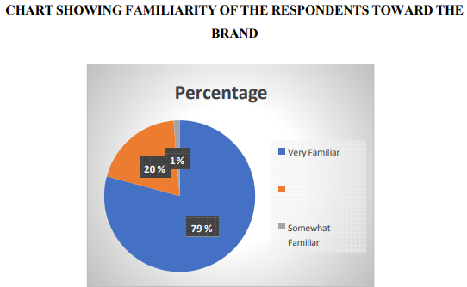
Figure 1: Familiarity Towards Puma
(Source: Amsaveni and Adityaa, 2024)
According to Figure 1, it can be interpreted that Puma highlights 79% of familiarity across the sports apparel industry (Amsaveni and Adityaa, 2024). According to Prakash (2025), Puma also incorporates high customer satisfaction with strong brand perception and digital experience. This brand also highlights 62% of consumer advocacy with 75% of repetitive purchasing intent. This company also adopts social media marketing to identify complaints effectively.

1.2. Research Rationale and Problem Statement
Puma has a good brand image with customer brand loyalty, but also there are some areas in which Puma need improve and increase. The key improvement points of Puma are durability, comfort, and affordability, along with customer service. Puma can increase customer satisfaction while sustaining these competitive advantages. Major competitors of Puma are Nike and Adidas, and Puma is competing against these brands in terms of customer experience (The Global Data, 2021). Brand trust results in the creation of long-term relationships since it reduces uncertainty and fear of opportunism (Ledikwe, 2020). This is a major topic for discussion since the customers who are loyal may end up purchasing from the brand and may even refer others to the brand.
Currently, Puma is facing different challenges in terms of customer experience in terms of high quality and brand loyalty. The challenges that the company might face in the future, such as developing a performance-based brand loyalty among its customers and major competitors (Sivasankar & Arunprakash, 2025). The customers might have faced challenges regarding the quality of the products being offered by the company, such as the shoe is disintegrating easily or the stitches coming apart. This might have given a feeling of disappointment to the customers since they want high-quality products from a premium brand (Kalaivani & Arockia, 2025). The study will highlight the mentioned issues related to customer experiences with brand loyalty for Puma.

1.3. Aims and Objectives of the Research
Aim:
This present research aims to demonstrate an analysis of the impact of customer experiences on brand loyalty towards Puma as a sports apparel brand within a global sports apparel market with high competition.
Objectives:
The research objectives of this present research are discussed below:
RO1: To identify the influence of multiple factors and the impacts on the customer experience by aligning with the repetitive purchasing behaviour and brand loyalty for Puma.
RO2: To determine the importance of customer experience in maintaining brand loyalty for Puma.
RO3: To acknowledge the major issues faced by Puma to provide an effective customer experience.
RO4: To recommend some strategies to mitigate the challenges faced by Puma to enhance the customer experience and build brand loyalty in the global market.

1.4. Research Questions
RQ1: How do the multiple factors influence the customer experience with the repetitive purchasing behaviour and brand loyalty for Puma?
RQ2: What is the importance of the customer experience in maintaining brand loyalty for Puma?
RQ3: What are the challenges faced by Puma to enhance the customer experience and build brand loyalty in the global market?
RQ4: What are the recommended strategies to mitigate the challenges faced by Puma to enhance the customer experience and build brand loyalty in the global market?

1.5. Significance of the Research
This present research can also highlight the relationship between the brand loyalty of Puma and its customer-centric approach. This research can also include the key factors of Puma’s products, such as the quality, durability and trendiness in characteristics. Moreover, this research will also focus on the technology-driven approach, convenience and personal shopping experience of the customers of Puma (Nachimuthu, 2024). This study can also enlighten the aspects of the loyal customer-base of Puma, including the Gen Z and Millennials.

2. Review of Existing Literature

2.1 Introduction
The market for sports apparel is a competitive market where customer experience has a major impact on building brand loyalty. This literature review seeks to explore the literature on customer experience, customer satisfaction, trust, and loyalty, especially on the brand Puma.

2.2 Influence and Impact of Different Factors on Customer Experience
The customer experience at Puma can be defined by a combination of high-quality product performance, fashion style, and a robust digital-first strategy that targets younger demographics and Gen Z. The factors that affect the customer experience include product comfort, brand image, price-performance ratio, and the ease of physical and digital purchase. According to Zou et al. (2025), digital technology and user-friendly online retail websites can improve the customer experience for sportswear shopping, especially for the younger generation, as digital technology can improve the convenience, interaction, and engagement of customers with digital platforms (Refer to Figure 2). On the other hand, Singh (2024) states that service quality, product quality, and reliability are major factors that can affect customer satisfaction. Overall, customer experience is based on service quality, product quality, and reliability with digital technology improvement.
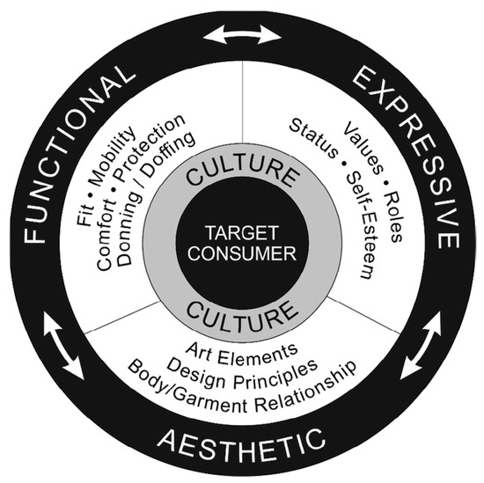
Figure 2: Product Quality Impact on Customer
(Source: Zou et al. 2025)

2.3 Necessity of consumer experience to maintain brand loyalty in the Sports ware industry
Consumer Experience (CX) is very important in building brand loyalty in the sportswear industry, given that the industry has moved beyond being product-based to being experiential, where experiences are valued higher than product attributes. Brand lifestyle congruence is found to have a significant impact on brand satisfaction, whereas brand satisfaction is also found to have a significant impact on purchase intentions (Acar et al., 2024). Figure 3 discusses the impact of brand identity, brand lifestyle congruence, brand satisfaction, and repurchase intention on family. On the other hand, Heo et al. (2023) examined the effects of product collaborations on sports consumers who were familiar with product collaborations related to sports shoes. The customer experience, brand identity, and lifestyle congruence are very important in influencing brand satisfaction and purchase intentions.
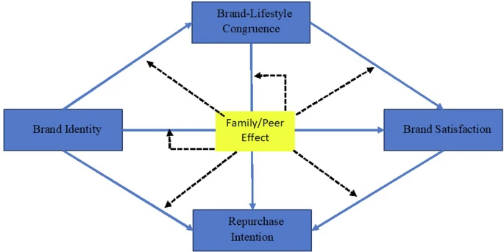
Figure 3: Consumer Experience to Brand Products
(Source: Acar et al., 2024)

2.4 Challenges Faced by Sport ware Brands in Providing a Good Customer Experience
Sportswear brands are dealing with a myriad of challenges in providing a high-quality customer experience (CX), which is largely attributed to the high rate of returns, the requirement for digital personalisation, the sustainability push, high quality and brand loyalty. An article by Mohammadi et al. (2024) shows that the biggest challenge for sports stores, to a certain extent, is how to manage the downward trend of their consumers’ tendency. It seems that the management of the customer experience can, to a certain extent, slow down the downward trend. Similarly, Sabarish and Sanjana (2025) state that the problem is the efficiency of psychological strategies on consumers' buying habits and brand preference. Overall, these studies show that there are various challenges, such as declining consumer interest, personalisation demands, changing buying behaviours, customer experience management and psychological marketing approaches.

2.5 Recommendation to enhance Customer Experience and Brand Loyalty in the Sports Apparel market
In order for a brand to enhance customer experience (CX) or brand loyalty in the competitive sports apparel market, it must change from a transactional or product-based approach to a relationship or experience-based approach. Based on the study of Ledikwe (2020), strengthening the relationship between brand awareness, brand image, brand trust, and brand commitment is a move to create true brand loyalty. On the other hand, Barbosa et al. (2025) suggest that identification of the importance of service quality and customer satisfaction implies that marketing strategies should continuously focus on improving these aspects in order to stimulate brand loyalty. The strengthening of brand relationships, service quality, and customer satisfaction is essential for improving customer experience.

2.6 Literature Gap
While there have been several studies conducted on customer experience and brand loyalty in the sportswear industry, very little research has specifically looked at how different factors, such as digital experience, product quality, service quality, and psychological strategies, impact customer loyalty towards Puma. This research will discuss the above mentioned point thoroughly, with recommendations.

2.7 Theoretical Underpinning

2.7.1 Philip Kotler's theory of customer satisfaction
Philip Kotler described customer satisfaction as a feeling of pleasure or displeasure derived from comparing a product's perceived performance with consumer expectations. It is a relative judgment following consumption, which depends on whether the perceived performance is below, meets, or exceeds consumer expectations. According to Salim et al. (2019), customer satisfaction is affected by tangible, reliability, responsiveness, empathy, and assurance factors, as shown in Figure 4.
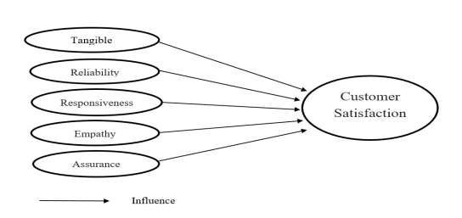
Figure 4: Customer Satisfaction Model
(Source: Salim et al. 2019)
If Philip Kotler’s theory of customer satisfaction is examined in relation to the sports apparel industry, it is described as a feeling of pleasure or displeasure derived from a comparison with one’s expectations regarding a product's performance in relation to his or her needs. Philip Kotler’s theory can be applied in relation to the sports apparel industry as a whole, as the sports apparel industry is a competitive industry that aims to satisfy customer expectations regarding product performance and prestige.

2.7.2 Expectancy-Disconfirmation Paradigm (EDP)
The Expectancy Disconfirmation Paradigm (EDP), which has been related to Oliver’s study of 1980, suggests that satisfaction is based on a comparison between expectations before purchase and performance after purchase (Wang & Fan, 2022). Positive disconfirmation leads to satisfaction, while negative disconfirmation leads to dissatisfaction (Refer to Figure 5).
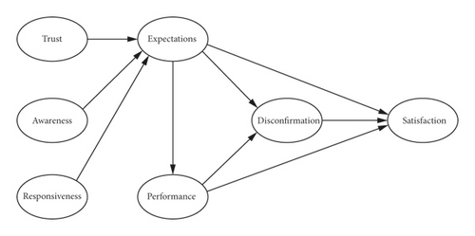
Figure 5: Expectancy-Disconfirmation Paradigm (EDP)
(Source: Wang and Fan, 2022)
The Expectancy Disconfirmation Paradigm (EDP) is related to customer experience and brand loyalty in the sports apparel business since it is a mental construct that measures consumer satisfaction based on a comparison between expectations before purchase (marketing and brand name) and performance after purchase (product performance). In the sports apparel business, positive disconfirmation, such as positive performance beyond expectations, for example, enhanced performance in sports activities, directly leads to customer delight.

2.8 Summary
The literature review for this study will be based on customer experience in relation to customer satisfaction, trust, and loyalty in the sports apparel industry, particularly Puma. It will include customer experience in terms of product quality, digital experience, and service quality; challenges in the industry; customer satisfaction theory; and Expectancy-Disconfirmation Paradigm theory for brand loyalty.

3. Methodology

3.1 Research Philosophy
The research philosophy used in this work is positivism and this research philosophy is founded on the assumption that the knowledge can be gained through observed and measurable facts. Positivism helps the researcher to examine connections among variables by using objective and empirical data (Waliaula, 2024). The philosophy fits the ongoing research because it is aimed at analyzing the existing data on the customer experience and brand loyalty in the sports apparel field. The research, by using already published publications, reports, and findings of the statistics, ensures objectivity and lowers subjectivity; hence, reliability and validity in the conclusion made about the strategies used by Puma in customer experience and their influence on brand loyalty.

3.2 Research Approach
The study adheres to the deductive methodology, i.e., it examines the current notions and hypotheses in the context of the obtained information. Deductive reasoning has general theories as its starting point and concludes on specific conclusions (Robinson and Rodriguez, 2025). The theoretical constructs that are used in this study include the Customer Satisfaction Theory by Kotler and Expectancy-Disconfirmation Paradigm (EDP) to comprehend the role of the customer experience in brand loyalty. These theories give a basis of analysing the major variables like quality of products, satisfaction of service and online involvement. The deductive method guarantees an organized and theory-based study and in the case of Puma, the study validates the available knowledge in the circumstances.

3.3 Research Strategy and Design.
This study uses the qualitative secondary research strategy that is laboring under the descriptive research design. Qualitative secondary research will enable the interpolation of the available literature and data to acquire profound information on customer behaviour and brand loyalty (Zou et al., 2025). The descriptive design is recommended as it allows conducting a systematic analysis of data without manipulating the variables and is also appropriate to study trends and relationships in the sports apparel industry. The research examines the dimensions of the customer experience that are important in the context of brand loyalty to Puma, such as product performance, online interaction, and service quality through the design.

3.4 Data Collection Method
The research is purely based on secondary data collection technique, which entails the collection of information on sources that are already published. These sources comprise academic publications that are peer-reviewed, industry reports, and company related publications that give an insight on customer experience and brand loyalty within the sports apparel industry. The benefit of secondary data is that it provides the access to big data and confirmed results, which increase the reliability of a research (Barbosa et al., 2025).
To maintain data quality, there are a few selection criteria applied, which include being relevant to the topic of the research, the authoritative source, and being published since the year 2019 to 2025. Puma and its competitor information are obtained using sources like ResearchGate, Google Scholar and industry analysis. The approach allows achieving an economical and time efficient method and at the same time, it is scholarly rigorous.

3.5 Data Analysis Technique
The thematic analysis is used to analyse the secondary data collected in the study. Thematic analysis is a method of identifying, analysing, and reporting patterns or themes of qualitative data (Heo et al., 2023). At the first stage, the data are viewed and then the information related to the research is coded in such categories like product quality, customer satisfaction, digital engagement, and brand trust. These codes are subsequently subdivided into bigger themes which provide an explanation as to how customer experience and brand loyalty relate to each other.
Besides this, a comparative analysis is done to compare the results of various studies to determine the similarities, differences and gaps in the research. Through this method of analysis, it is possible to have a holistic view on the impact of different factors on customer loyalty within the framework of Puma.

3.6 Ethical Considerations
The credibility and integrity of the research is dependent on ethical aspects. The paper also complies with the ethical standards because only publicly available and credible sources of secondary data have been used. Every reference is cited in a suitable way by using Harvard referencing whereby original authors get their due credit (Rahman and Muktadir, 2021).
Moreover, the data have no manipulations and misrepresentation, which ensures transparency and truthfulness throughout the study. Since there is no primary data to be gathered, there are no problems with the consent of participants and confidentiality. All in all, the study observes academic integrity and ethical provisions in the pursuit of secondary research.

4. Expected findings
The study on Puma shows that product quality, digital engagement, and service satisfaction are major contributors to customer experience, which is likely to have a positive relationship with brand loyalty. The study shows that factors such as fashion style, ease of purchase, and brand trust have strong correlations with customers’ intentions to repurchase or recommend the brand. Also, the study gives some quantitative insights into strategies aimed at increasing customer satisfaction and building brand loyalty in a competitive Puma brand environment.

5. Limitations
The study carried out in Puma has some limitations. First, the use of a quantitative survey method that employs closed-ended questions might limit the respondents from presenting detailed opinions. Second, the use of 125 customers from Puma selected via convenience and purposive sampling might not be a good representation of the entire population of customers. Thirdly, the data collected may also lead to response bias. Finally, the study mainly focuses on those factors that affect the customer experience, such as the quality of the product, digital engagement, etc. However, it may not take into consideration other factors that may affect the external environment.

6. Timeframe
Tasks | Week 1-2 | Week 3-4 | Week 5-6 | Week 7-8 | Week 9-10 | Week  11-12 | Week 13-14 | Week15-16
Research Topic Selection
Existing Literature Review
Research Method Selection
Selection of Data Collection Method
Research Data Analysis
Writing the Chapters (1–3)
Writing the Chapters (4–5)
Conclusion & Recommendations
Proofreading & editing
Table 1: Gantt Chart

7. Conclusion
The current research on Puma is a testament to the impact of customer experience on brand loyalty in the competitive sports apparel industry. Parameters such as product quality, digital engagement, satisfaction with services, and style are likely to impact brand loyalty. Despite the challenges that these factors may pose to an entity, such as the demands for personalisation and consumer behaviour, managing these challenges will prove to be advantageous in achieving customer satisfaction. The results will be advantageous to Puma in enhancing its ustomer-centric strategies for a competitive advantage in the in the international sportswear market.

References
Acar, A., Büyükdağ, N., Türten, B., Diker, E. and Çalışır, G. (2024). The Role of Brand identity, Brand Lifestyle congruence, and Brand Satisfaction on Repurchase intention: a multi-group Structural Equation Model. Humanities and Social Sciences Communications, 11(1). doi:https://www.nature.com/articles/s41599-024-03618-w.
Amsaveni, Dr.N. and Adityaa, K.B. (2024). A STUDY ON CUSTOMER PERCEPTION AND BRAND LOYALTY OF PUMA BRAND. Available at: https://www.researchgate.net/profile/Amsaveni-Nachimuthu/publication/381828431_A_STUDY_ON_CUSTOMER_PERCEPTION_AND_BRAND_LOYALTY_OF_PUMA_BRAND/links/668039870a25e27fbc17012a/A-STUDY-ON-CUSTOMER-PERCEPTION-AND-BRAND-LOYALTY-OF-PUMA-BRAND.pdf [Accessed 13 Mar. 2026].
Barbosa, R.L.C., Rincón, A.G. and Saavedra, N.O. (2025). Welcome To Zscaler Directory Authentication. [online] Ijirss.com. Available at: https://ijirss.com/index.php/ijirss/article/download/6042/1124/9562 [Accessed 13 Mar. 2026].
Happ, E., Scholl-Grissemann, U., Peters, M. and Schnitzer, M. (2020). Insights into customer experience in sports retail stores. International Journal of Sports Marketing and Sponsorship, 22(2). doi:https://doi.org/10.1108/ijsms-12-2019-0137. [Accessed 13 Mar. 2026]
Heo, Y., Pedersen, Z., Williams, A. and Byon, K. (2023). An Examination of Consumer’s Brand Loyalty and Purchase Intention Toward Collaborations in the Sport Brand Footwear Industry. Sport marketing quarterly, 32(4), pp.320–331. doi:https://doi.org/10.32731/smq.324.122023.04.
Kalaivani, M.R. and Arockia, S.R.F. (2025). A Study on Consumer Satisfaction Towards Puma Products with Reference To Coimbatore City. [online] https://ijrpr.com/. Available at: https://ijrpr.com/uploads/V6ISSUE4/IJRPR42873.pdf [Accessed 13 Mar. 2026].
Ledikwe, A. (2020). Determinants of brand loyalty in the apparel industry: A developing country perspective. Cogent Business & Management, [online] 7(1). doi:https://doi.org/10.1080/23311975.2020.1787736.
Mohammadi, S., Abed Mahmoudian and Alonso, M. (2024). Customer Experience Design in Sportswear Retail Stores. Emerald Publishing Limited eBooks, pp.137–152. doi:https://doi.org/10.1108/978-1-83797-276-020241010.
Nachimuthu, A. (2024). A STUDY ON CUSTOMER PERCEPTION AND BRAND LOYALTY OF PUMA BRAND. ResearchGate. Available at: https://www.researchgate.net/publication/381828431_A_STUDY_ON_CUSTOMER_PERCEPTION_AND_BRAND_LOYALTY_OF_PUMA_BRAND [Accessed 13 Mar. 2026].
Prakash, S. (2025). Research Report on Industry ‘An Analysis of Puma’s Online Presence and Consumer Involvement’. ResearchGate. Available at: https://www.researchgate.net/publication/392753329_Research_Report_on_Industry_An_Analysis_of_Puma [Accessed 13 Mar. 2026].
Rahman, A. and Muktadir, G. (2021). SPSS: An Imperative Quantitative Data Analysis Tool for Social Science Research. [online] ResearchGate. doi:https://doi.org/10.47772/IJRISS.2021.51012.
Robinson, O.C. and Rodriguez, D.B. (2025). Deductive qualitative research: an integrative approach to designing studies. Qualitative Research in Psychology, 23(2), pp.1–16. doi:https://doi.org/10.1080/14780887.2025.2604773.
Sabarish, M. and Sanjana, R. (2025). International Journal of Research Publication and Reviews Neuromarketing Strategies: A Comparative Study of Nike and Puma. International Journal of Research Publication and Reviews, [online] 6(9), pp.5319–5324. doi:https://doi.org/10.55248/gengpi.6.0925.3576.
Salim, M., Bachri, S. and Febliansa, M.R. (2019). Customer Satısfactıon (Publıc Satısfactıon) on Servıces in Admınıstratıve Vıllage Offıce. Asia Pacific Management and Business Application, 007(01), pp.17–30. doi:https://doi.org/10.21776/ub.apmba.2018.007.01.2.
Singh, N. (2024). Service quality expectations of international fashion apparel brands in India: Satisfaction loyalty and the mediating role of culture. Fashion, style & popular culture. doi:https://doi.org/10.1386/fspc_00259_1.
The Global Data (2021). Puma SE Peers & Key Competitors - GlobalData. [online] Globaldata.com. Available at: https://www.globaldata.com/company-profile/puma-se/competitors/ [Accessed 13 Mar. 2026].
Waliaula, A.J. (2024). Positivism | EBSCO. [online] EBSCO Information Services, Inc. | www.ebsco.com. Available at: https://www.ebsco.com/research-starters/religion-and-philosophy/positivism [Accessed 13 Mar. 2026].
Wang, P. and Fan, F. (2022). Examining and Expanding the Expectancy Disconfirmation Model: Evidence from Rural China. Discrete Dynamics in Nature and Society, 2022, pp.1–11. doi:https://doi.org/10.1155/2022/9378101.
Zou, Y., Zhao, C., Childs, P., Luh, D. and Tang, X. (2025). User Experience Design for Online Sports Shoe Retail Platforms: An Empirical Analysis Based on Consumer Needs. Behavioral Sciences, [online] 15(3), pp.311–311. doi:https://doi.org/10.3390/bs15030311.

